Re-creation of Bugatti EB110 GT for home driving simulator and Virtual Reality.

(open-source, free, enthusiast project)

*Version 0.11 alpha (for Assetto Corsa) 2022-01-11 Apache-2.0 license*

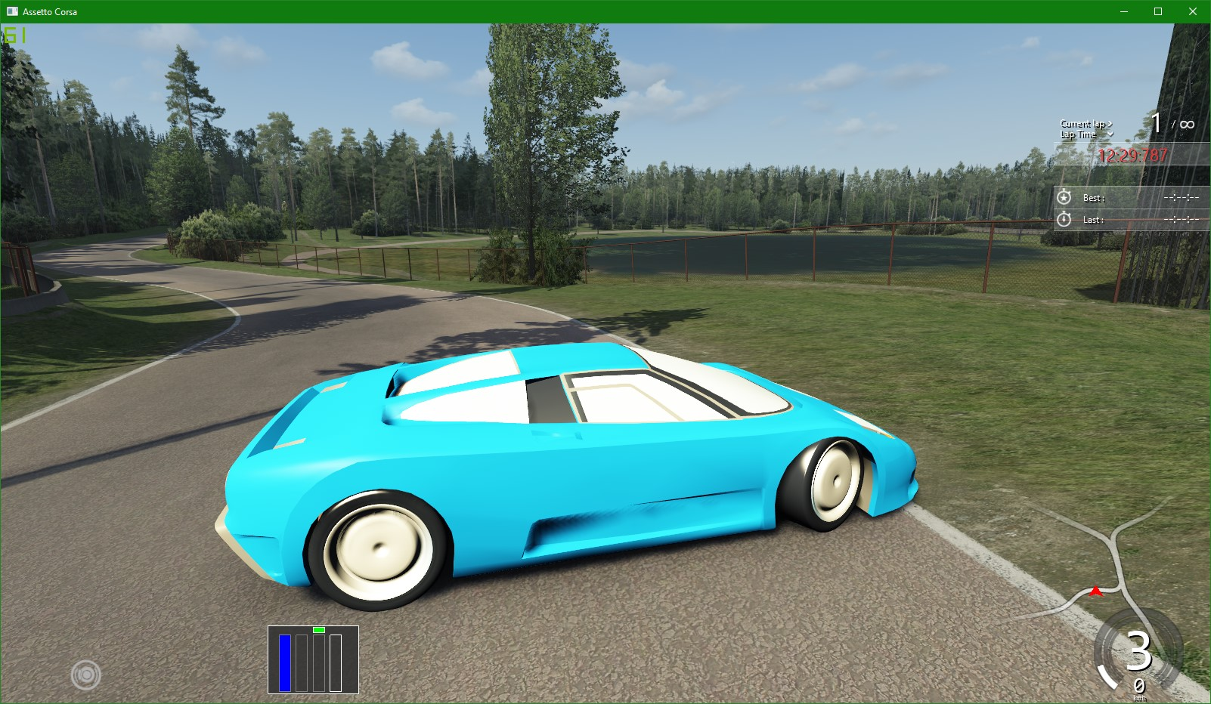

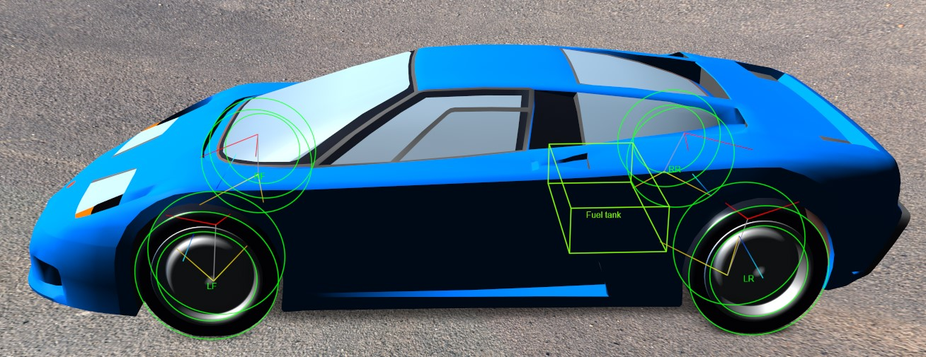

Contents

Why? 3

What? 4

3D model of exterior and interior 4

The Data 4

Audio (optional) 4

The Data 5

Suspension & Handling (suspension.ini) 5

Electronic systems (electronics.ini) 16

Tires (tire.ini) 18

Engine data (engine.ini) 36

Transmission data (drivetrain.ini) 44

Brakes (Brakes.ini) 52

Aerodynamics (aero.ini) 54

Instrumentation (analog_instruments.ini & digital_instruments.ini) 65

General data (weight & dimensions, car.ini) 65

Important notes about Data sources 73

Sources of Data 74

## Why?

The Bugatti EB110 is an iconic car that was created by an amazing team. EB110 touched the hearts of thousands of car enthusiasts around the world, but only less than 200 lucky people can actually own one. Not only is this machine rare and expensive to own, but because of its cult status most of the lucky people who own one will rarely have an opportunity to unleash its full power – risk of damaging the low-mileage example, lack of time to travel to a suitable track, lack of experience, lack of raw skill, etc.

If we make an authentic virtual re-creation of Bugatti EB110 based on the [Assetto Corsa](https://store.steampowered.com/app/244210/Assetto_Corsa/) driving simulator it will be great for everyone:

* It will be possible to instantly drive virtual EB110 GT on most tracks around the world. There are excellent laser-scanned models of famous tracks in the original [Assetto Corsa](https://store.steampowered.com/app/244210/Assetto_Corsa/), but the countless community made tracks include surprisingly many local and historical tracks as well as amazing open-road courses (for example see [here](https://youtu.be/fAUWb8qE-OY), [here](https://www.racedepartment.com/downloads/categories/ac-tracks.8/) and [here](http://assetto-db.com/tracks/latest)).
* Just like professional drivers, owners and enthusiasts of EB110 will be able to safely practice driving the car at the limit without the risks of damage.
* Using Virtual Reality glasses, thousands of people who never even saw EB110 in real life will be able to feel like sitting and driving in an actual car.

As for me, I personally was about 9 years old when I got fascinated with EB110 – that was 1995. I would call EB110 my favorite supercar of all time. I think EB110 is worth simulating as this is probably the greatest car for virtual driving – it has proper manual gearbox and no stability control systems. I may not be the most skilled 3D artist or the best at tuning the virtual handling, but I can get things started, share all data, 3D files and physics setup with enthusiasts on the Internet. True enthusiast community can make this virtual EB110 better than any company would do for money. Regarding just car modeling experience – many years ago I did the model of another car I really like – [Saab 9000](https://www.racedepartment.com/threads/bikernieki-race-track.140879/post-3035155) (this is an example that I have finished similar projects before).

Note that today there is a rather nice digital version of [Bugatti EB110SS in the Forza games](https://forza.fandom.com/wiki/Bugatti_EB110_Super_Sport) – both in Forza Motorsport which is fairly realistic racing game and in Forza Horizon series which is not trying to be a simulator. The 3D model in these games is quite good and hopefully accurate, but I don’t believe the physics and handling is accurate in the Forza version as nobody knows how they tuned their virtual car model handling.

## What?

The plan is to make accurate model of a production Bugatti EB110 GT. Perhaps SuperSport could be covered as well, but the GT is the primary focus to begin with. (EB110 SS is faster but in 2020 there are lots of other cars that are even faster, so there is no need to chase absolute top performance). The complete model will be as realistic as possible, matching some actual production GT models. There should be **no infringement on someone’s intellectual property** – all model content will be created from scratch, no re-use (conversions) of any existing not-open-source EB110 models and assets.

The complete model will need:

### 3D model of exterior and interior

Because there is a great example of Forza version of Bugatti EB110 and a lot of images online, it is fairly straightforward to make accurate 3D model of the car. It is time consuming and requires some skill, but will be done. To begin with, a placeholder 3D model will be used for tuning the handling and physics.

What could be useful for maximum authenticity (not necessary, but very nice to have):

* Technical drawings of wheels, seats, interior parts – door panels, floor console, pedals, carpets, instruments or other details.
* Interior and exterior details photos that are suitable for [photo-scanning](https://youtu.be/k4NTf0hMjtY?t=80). With this technique it is relatively easy to get 3D reference for surfaces that are difficult to measure or describe in technical drawings (interior, seats, etc.)
* 3D scan of the car? With the right hardware it should be fairly easy to scan one of the real cars for absolute precision.

### The Data

All the details of the performance and setup. As Assetto Corsa has quite realistic physics engine, most of the car handling setup is based on actual physics.

### Audio (optional)

Sound of the engine, wastegates, gearbox shifting, etc. This is a special topic. A lot can be done with suitable YouTube videos. But ideally sounds are recorded in sync both on the outside and in the passenger seat on head level while camera records tachometer and engine goes through full range from idle to rev-limiter and down to idle. + gear shift sounds. This is optional, only in case something like this is possible to arrange.

Sound detail: "Turbos exhale sequentially left to right, left to right." ([Source](https://www.whichcar.com.au/reviews/car-comparisons/bugatti-chiron-vs-bugatti-veyron-vs-bugatti-eb110-comparison))

## The Data

Here is a list of all data that is needed, what values are used right now and the data sources. Please fill in any missing information.

### Suspension & Handling (suspension.ini)

**Open Questions:**

1. Antiroll bar stiffness (Front & Rear)?
2. Height of Center of Gravity in the front and rear?
3. Hub mass in the front and in the rear (masse sospese anteriori)? For unsprung weight.
4. Toe-out (front and rear)?
5. Spring rate (front and rear)? Preferably we need effective Wheel rate stiffness in Nm.
6. Progressive spring rate in N/m/m (front and rear)? Note, according to “Sport Auto, n375” magazine the springs are progressive where Front = 90 to 210 N/mm and Rear = 62 to 82 N/mm.
7. Please confirm that “scual. pneum. sup.= 67.85mm inf. = 64.2 mm" means bump stop up and down from normal suspension position?
8. Bump stop spring rate (front and rear)? not very important.
9. Total suspension movement range, before hitting packers (front and rear)?
10. Damper wheel rate stifness in N sec/m in compression (front and rear)?
11. Damper wheel rate stiffness in N sec/m in fast speed compression (front and rear)?
12. Damper bump slow/fast threshold in seconds (front and rear)?
13. Damper wheel rate stiffness in N sec/m in slow speed rebound (front and rear)?
14. Damper wheel rate stiffness in N sec/m in fast speed rebound (front and rear)?
15. Damper rebound slow/fast threshold in seconds (front and rear)?
16. (Please clarify if data for rear spings and dampers is for both together or for each one and has to be multiplied by 2 for each rear wheel?)
17. Any additional notes about handling and suspension that can be useful?

Assetto Corsa accurately models double wishbone suspensions with all values referenced to the wheel center (X-ToCenter, Y-Up, Z-Forward):

“Kunos answer: The 0,0,0 reference point is at the center of the touch point between HUB and RIM”

[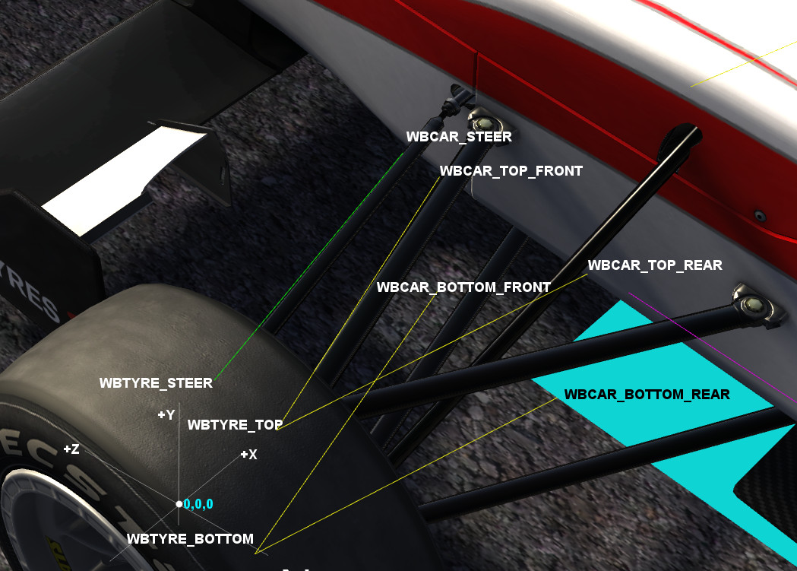](https://www.assettocorsa.net/forum/index.php?threads/physics-questions-thread-tip-database-in-3rd-post.11408/#post-176943) (image by [Stereo](https://www.assettocorsa.net/forum/index.php?threads/physics-questions-thread-tip-database-in-3rd-post.11408/#post-176943))

**Overall handling info:**

WHEELBASE = 2,550 mm (from all sources)

Roll Center height Rear = **113.1** mm (from “Rear Susp. schematics 08-10-1993”)

Roll Center height Front = **59.3** mm (from “Front Susp. schematics 08-10-1993”)

Lateral acceleration on a 120m skidpad = **0,99g** (according to “”)

Handling balance (on a skidpad) = **“mild understeer”** (according to “”) **“only radical fooling with the throttle or heavy trail-braking brings out the tail”**

Speed through 700feet (213m) slalom = 103 km/h (according to “”)

Handling balance (in slalom) = “neutral” (according to “”)

Handling according to “”: “By contrast, I sure hope they don’t mess with the EB110’s ride and handling, because these are well nigh hyper-exotically perfect.” “The Bugatti circled the pad in a most benign manner, its tires barely audible [on moderate grip surface], the car **exhibiting just a little understeer**. When I tired pushing a tad harder, it responded by scrubbing off a little more speed and actually developing a bit less lateral acceleration. **Abrupt liftoff**, usually the bane of mid-engine hyperexotics, generated nothing more than the slightest tuck-in. In fact, **the only way I could get the EB 110 sideways was through a deliberate pitch-and-catch**.” “Ride wasn’t horrid, even along sections of Michelin’s carefully simulated freeway chop, tar strips and potholes. An impressive combination.”

Handling according to “”: “Where this car really scores is in its security, the ease at which you can travel at an amazing pace. In the wet at the Combe, it’s quicker into every corner than the other two cars, which cause moments of sheer terror as their back wheels slew them sideways. There’s no such trouble in the Bugatti: it **turns in crisply, neutral out as you apply the power, and remains on an even kneel at all times**. No matter how hard I try, I can’t powerslide the Bugatti, though Kacher manages it by sheer animalism.

However, the Bugatti doesn’t communicate that well. **The power steering is meatily weighted, accurate and direct, but never supplies the feedback you get from a single-seater or sports-racer**, where the steering talks you through any handling problems. **The brakes are the best of this group**, though, having wonderful feel and the stopping power of an arrestor wire on an aircraft carrier

(..) the Bugatti, which benefits from an easier clutch and gearshift, and **slightly better ride that suffers a touch from floatiness over crests**. It’s more of a pleasure to be in the Bugatti (..)

Of the three, the Bugatti is the rational choice, the car that combines the speed and dynamics of a supercar with the ride, comfort and usability of the workday car. It lacks the ultimate exhilaration of the F40, but makes up for it by being the only one that **could be used every day on the road. Average drivers could enjoy the Bugatti at speed**, whereas the other two are purely for the skilled and the brave [F40 and XJ220].”

Another handling impression by a professional driver: <https://youtu.be/hHwFpoIA84g?t=79>

**suspension.ini:**

|  |  |  |  |  |
| --- | --- | --- | --- | --- |
| Is OK? | Parameter | Value | Explanation | Data Source |
| OK | WHEELBASE= | 2.550 m | Wheelbase distance in meters | “” |
| OK | CG_LOCATION= | 0.42 | Front Weight distribution in percentage | “” data: Front/Rear = 42.4/57.6%  “” data: Front/Rear = 43/57%  “” data: Front/Rear = 42/58%  Nicola Materazzi said 40/60% <https://youtu.be/hVOEOEJAceI?t=663> |
| Help! | [ARB] FRONT= | 26500 N/m | Front antiroll bar stiffness. in Nm  “ARB units are N/m (Newtons/difference in displacement at the wheel)”  “You have to consider that AC does not consider the torsional rigidity of the chassis so the ARB is applied to an infinitely rigid chassis and is not representative of the real one. You should instead calculate the real roll angle and then adapt the ARBs to get it in game.”  “if you want to do some cinematic calculations I can tell you that usual roll angle values at 1 G for passenger cars starts from 6 or 7 for small economic cars, passes trough 4 or 5 for medium class and goes to 2.5 or 3 for sport cars. Those values are an average between front and rear, usually much of the stiffness is on the front so if you want to use 4° you can set 3.5° front and 4.5° rear...” (abbo90) | Inspired by Nissan R34 GT-R |
| Help! | [ARB] REAR= | 13000 N/m | Rear antiroll bar stiffness. in Nm  More info See above^ | Inspired by Nissan R34 GT-R |
|  |  |  |  |  |

**[FRONT]** Suspension data

|  |  |  |  |  |
| --- | --- | --- | --- | --- |
| Is OK? | Parameter | Value | Explanation | Data Source |
|  | **[FRONT]** |  |  |  |
| OK | TYPE= | DWB | Double wishbone (can also be McPherson “STRUT” or solid “[AXLE](https://www.assettocorsa.net/forum/index.php?threads/how-do-i-increase-the-suspension-height-of-a-custom-car.46882/#post-914963)”) | “” |
| Help! | BASEY= | **0.4 ?** - tireRADIUS=  = 0.4 - 0.3266 =  = 0.074 m | ??? <https://www.assettocorsa.net/forum/index.php?threads/cog-height-calculation.54541/> discusses this, (need to figure this out.)  ; Distance of CG (center of gravity) from the center of the wheel in meters. Front Wheel Radius-BASEY=front CoG. Actual CG height =(FWR-FBasey)+(RWR-Rbasey))/CG_LOCATION%  “BASEY is the Center of gravity height (minus the wheel radius)”  “Basey is the distance from the CoG to the axle, so negative means the axle is below the CoG.”  “CG height is around 540 - 560 mm for normal passenger cars so -0.225 -0.235 is normal for BaseY” | What is the height of Center of Gravity in the front?  Roll Center height Front = **59.3** mm (from “Front Susp. schematics 08-10-1993”) |
| OK | TRACK= | 1. 55548 m (calculated based on 0.5deg camber) | Track width in meters (from pivot 3D placement of the 3d model of a wheel) | “Front Susp. schematics 08-10-1993” Track width = 1550.00 mm (at the ground!) |
| ??? | ROD_LENGTH= | 0.00 m | ??? probably should be Zero?  ; push rod length in meters. positive raises ride height, negative lowers ride height. |  |
| OK | RIM_OFFSET= | 0.0 | ??? probably should be Zero? |  |
| Help! | HUB_MASS= | 57.5 | ; masse sospese anteriori  You can confirm this in the dev app "car engineer" as  ***unsprung mass*** *= (HUB_MASS_Front *2)* TypeMod_Front +( HUB_MASS_Rear *2) * TypeMod_Rear*  Where TypeMod is 0.8 for STRUT and 1.0 for DWB  “if you have STRUT as suspension type, only 80% of the HUB_MASS is considered unsprung. HUB_MASS is per corner not total” “And in TYPE=DWB it is simply: 2*mass value indicated in the file” ([source](https://www.assettocorsa.net/forum/index.php?threads/understand-the-unsprung-mass-in-ac.60080/#post-1087415)) | Inspired by Nissan R34 GT-R (same wheel size)  Note: Typical Tire Weight = 13kg  BSS GT Fr. wheel weight = 8kg |
| OK | WBCAR_TOP_FRONT= | See Source files or the .ini file | Coordinates in meters for double wishbone suspension points | “Front Susp. schematics 08-10-1993” |
| OK | WBCAR_TOP_REAR= | See Source files or the .ini file | Coordinates in meters for double wishbone suspension points | “Front Susp. schematics 08-10-1993” |
| OK | WBCAR_BOTTOM_FRONT= | See Source files or the .ini file | Coordinates in meters for double wishbone suspension points | “Front Susp. schematics 08-10-1993” |
| OK | WBCAR_BOTTOM_REAR= | See Source files or the .ini file | Coordinates in meters for double wishbone suspension points | “Front Susp. schematics 08-10-1993” |
| OK | WBTYRE_TOP= | See Source files or the .ini file | Coordinates in meters for double wishbone suspension points | “Front Susp. schematics 08-10-1993” |
| OK | WBTYRE_BOTTOM= | See Source files or the .ini file | Coordinates in meters for double wishbone suspension points | “Front Susp. schematics 08-10-1993” |
| OK | WBCAR_STEER= | See Source files or the .ini file | Coordinates in meters for steering rod points | “Front Susp. schematics 08-10-1993” |
| OK | WBTYRE_STEER= | See Source files or the .ini file | Coordinates in meters for steering rod points | “Front Susp. schematics 08-10-1993” |
| Help! | TOE_OUT= | -0.00010 | ; Toe-out expressed as the length of the steering arm in meters | Inspired by Ferrari F40 |
| OK | STATIC_CAMBER= | 0.5 | ; Static Camber in degrees. Actual camber relative to suspension geometry and movement, check values in game  Format conversion: 0°30' = 0° + 30'/60 = 0.5° | “Front Susp. schematics 08-10-1993” camber: 0°30' = **0.5 deg** |
| Help! | SPRING_RATE= | 60000 | ; Wheel rate stifness in Nm. Do not use spring value but calculate wheel rate  (N/m spring rate / wheel rate in suspension.ini, displays kN/m or N/mm in ingame setup screen)  “Spring and Damping rates are at corner and at wheel so the must be multiplied for Motion Ratio squared. Then adjust Ride Height until you get the same amount of Camber front/rear you put in suspension.ini.  If you don't have dampers data start using 0.4 of critic damping for slow bump, 0.25 fast; 0.6 slow rebound, 0.45 fast. Speeds around 0.04.  Then adjust them in function of feedback...” (abbo90) | Inspired by Maserati Quattroporte  According to “” the front springs are progressive = **90 to 210 N/mm** |
| Help! | PROGRESSIVE_SPRING_RATE= | 800 | ; progressive spring rate in N/m/m | Inspired by Ferrari F40 |
| Help! | BUMP_STOP_RATE= | 80000 | ; bump stop spring rate | Inspired by Nissan R34 GT-R |
| Help! | BUMPSTOP_UP= | 0.068 | ; meters to upper bumpstop from the 0 design of the suspension | “scual. pneum.” **sup.= 67.85mm inf. = 64.2 mm** (from “Front Susp. schematics 08-10-1993”) |
| Help! | BUMPSTOP_DN= | 0.064 | ; meters to bottom bumpstop from the 0 design of the suspension | “scual. pneum.” **sup.= 67.85mm inf. = 64.2 mm** (from “Front Susp. schematics 08-10-1993”) |
| Help! | PACKER_RANGE= | 0.120 | ; Total suspension movement range, before hitting packers | Inspired by Nissan R34 GT-R |
| Help! | DAMP_BUMP= | 3597 | ; Damper wheel rate stifness in N sec/m in compression | Inspired by Nissan R34 GT-R |
| Help! | DAMP_FAST_BUMP= | 1978.4 | ; Damper wheel rate stiffness in N sec/m in fast speed compression | Inspired by Nissan R34 GT-R |
| Help! | DAMP_FAST_BUMPTHRESHOLD= | 0.080 | ; Damper bump slow/fast threshold in seconds | Inspired by Nissan R34 GT-R |
| Help! | DAMP_REBOUND= | 8730.9 | ; Damper wheel rate stiffness in N sec/m in slow speed rebound | Inspired by Nissan R34 GT-R |
| Help! | DAMP_FAST_REBOUND= | 4452.8 | ; Damper wheel rate stiffness in N sec/m in fast speed rebound | Inspired by Nissan R34 GT-R |
| Help! | DAMP_FAST_REBOUNDTHRESHOLD= | 0.110 | ; Damper rebound slow/fast threshold in seconds | Inspired by Nissan R34 GT-R |

**[REAR]** Suspension data

|  |  |  |  |  |
| --- | --- | --- | --- | --- |
| Is OK? | Parameter | Value | Explanation | Data Source |
|  | **[REAR]** |  |  |  |
| OK | TYPE= | DWB | Double wishbone | “” |
| Help! | BASEY= | **0.4 ?** - tireRADIUS=  = 0.4 - 0.3266 =  = 0.074 m | ??? <https://www.assettocorsa.net/forum/index.php?threads/cog-height-calculation.54541/> discusses this, (need to figure this out.)  ; Distance of CG (center of gravity) from the center of the wheel in meters. Rear Wheel Radius-BASEY=Rear CoG Actual CG height =(FWR-FBasey)+(RWR-Rbasey))/CG_LOCATION%  “BASEY is the Center of gravity height (minus the wheel radius)” | What is the height of Center of Gravity in the rear?  Roll Center height Rear = **113.1** mm (from “Rear Susp. schematics 08-10-1993”) |
| OK | TRACK= | 1.59942 m (calculated based on 1.75deg camber) | Track width in meters (from pivot 3D placement of the 3d model of a wheel) | “Rear Susp. schematics 08-10-1993” Track width = 1618.60 mm (at the ground!) |
| ??? | ROD_LENGTH= | 0.00 m | ??? probably should be Zero?  ; push rod length in meters. positive raises ride height, negative lowers ride height. |  |
| OK | RIM_OFFSET= | 0.0 | ??? probably should be Zero? |  |
| Help! | HUB_MASS= | 71.5 | ; masse sospese  You can confirm this in the dev app "car engineer" as  ***unsprung mass*** *= (HUB_MASS_Front *2)* TypeMod_Front +( HUB_MASS_Rear *2) * TypeMod_Rear*  Where TypeMod is 0.8 for STRUT and 1.0 for DWB  “if you have STRUT as suspension type, only 80% of the HUB_MASS is considered unsprung. HUB_MASS is per corner not total” “And in TYPE=DWB it is simply: 2*mass value indicated in the file” ([source](https://www.assettocorsa.net/forum/index.php?threads/understand-the-unsprung-mass-in-ac.60080/#post-1087415)) | Inspired by Nissan R34 GT-R (rough estimate)  Note: Typical Tire Weight = 18kg  BSS GT Rear. wheel weight = 8.8kg |
| OK | WBCAR_TOP_FRONT= | See Source files or the .ini file | Coordinates in meters for double wishbone suspension points | “Rear Susp. schematics 08-10-1993” |
| OK | WBCAR_TOP_REAR= | See Source files or the .ini file | Coordinates in meters for double wishbone suspension points | “Rear Susp. schematics 08-10-1993” |
| OK | WBCAR_BOTTOM_FRONT= | See Source files or the .ini file | Coordinates in meters for double wishbone suspension points | “Rear Susp. schematics 08-10-1993” |
| OK | WBCAR_BOTTOM_REAR= | See Source files or the .ini file | Coordinates in meters for double wishbone suspension points | “Rear Susp. schematics 08-10-1993” |
| OK | WBTYRE_TOP= | See Source files or the .ini file | Coordinates in meters for double wishbone suspension points | “Rear Susp. schematics 08-10-1993” |
| OK | WBTYRE_BOTTOM= | See Source files or the .ini file | Coordinates in meters for double wishbone suspension points | “Rear Susp. schematics 08-10-1993” |
| OK | WBCAR_STEER= | See Source files or the .ini file | Coordinates in meters for steering rod points  “The rear "_STEER" is a tie-rod and in typical suspension geometry is coplanar with one of the wishbones - so it looks like a rectangle instead of a triangle, and you can just code it in as such.” – this is true for EB110 as well. | “Rear Susp. schematics 08-10-1993” |
| OK | WBTYRE_STEER= | See Source files or the .ini file | Coordinates in meters for steering rod points | “Rear Susp. schematics 08-10-1993” |
| Help! | TOE_OUT= | 0.0006 | ; Toe-out expressed as the length of the steering arm in meters | Inspired by Ferrari F40 |
| OK | STATIC_CAMBER= | -1.75 | ; Static Camber in degrees. Actual camber relative to suspension geometry and movement, check values in game  Format conversion: 1°45' = 1° + 45'/60 = 0.5° | “Rear Susp. schematics 08-10-1993” camber: -1°45' = -**1.75 deg** |
| Help! | SPRING_RATE= | 55000 | ; Wheel rate stifness in Nm. Do not use spring value but calculate wheel rate  (N/m spring rate / wheel rate in suspension.ini, displays kN/m or N/mm in ingame setup screen)  “Spring and Damping rates are at corner and at wheel so the must be multiplied for Motion Ratio squared. Then adjust Ride Height until you get the same amount of Camber front/rear you put in suspension.ini.  If you don't have dampers data start using 0.4 of critic damping for slow bump, 0.25 fast; 0.6 slow rebound, 0.45 fast. Speeds around 0.04.  Then adjust them in function of feedback...” (abbo90) | Inspired by Maserati Quattroporte  According to “” the rear springs are progressive = **62 to 82 N/mm (not clear if this is total or must be multiplied by 2 due to double springs)** |
| Help! | PROGRESSIVE_SPRING_RATE= | 1200 | ; progressive spring rate in N/m/m | Inspired by Ferrari F40 |
| Help! | BUMP_STOP_RATE= | 100000 | ; bump stop spring rate | Inspired by Nissan R34 GT-R |
| Help! | BUMPSTOP_UP= | 0.075 | ; meters to upper bumpstop from the 0 design of the suspension | “scual. pneum.” **sup.= 75.14mm inf. = 61.85 mm** (from “Rear Susp. schematics 08-10-1993”) |
| Help! | BUMPSTOP_DN= | 0.062 | ; meters to bottom bumpstop from the 0 design of the suspension | “scual. pneum.” **sup.= 75.14mm inf. = 61.85 mm** (from “Rear Susp. schematics 08-10-1993”) |
| Help! | PACKER_RANGE= | 0.110 | ; Total suspension movement range, before hitting packers | Inspired by Nissan R34 GT-R |
| Help! | DAMP_BUMP= | 2517.9 | ; Damper wheel rate stifness in N sec/m in compression | Inspired by Nissan R34 GT-R |
| Help! | DAMP_FAST_BUMP= | 1510.7 |  | Inspired by Nissan R34 GT-R |
| Help! | DAMP_FAST_BUMPTHRESHOLD= | 0.080 |  | Inspired by Nissan R34 GT-R |
| Help! | DAMP_REBOUND= | 4087.5 | ; Damper wheel rate stifness in N sec/m in rebound | Inspired by Nissan R34 GT-R |
| Help! | DAMP_FAST_REBOUND= | 2656.9 |  | Inspired by Nissan R34 GT-R |
| Help! | DAMP_FAST_REBOUNDTHRESHOLD= | 0.110 |  | Inspired by Nissan R34 GT-R |

**NOTES:**

### Electronic systems (electronics.ini)

**Open Questions:**

1. ABS SLIP_RATIO_LIMIT (percentage of slip allowed before ABS starts working)?
2. ABS working/update frequency?
3. Was there only 1 ABS channel or more?

|  |  |  |  |  |
| --- | --- | --- | --- | --- |
| Is OK? | Parameter | Value | Explanation | Data Source |
|  | **[ABS_V2]** |  |  |  |
| Help! | SLIP_RATIO_LIMIT= | 0.11 | percentage of slip before ABS kicks in | Factory data or tuning could be helpful.  Inspired by BMW E30 M3 |
| ok? | CURVE= |  |  | Typical value in Assetto Corsa |
| OK | PRESENT= | 1 |  | “” &  “” & “” data: ABS by Bosch is standard. |
| OK | ACTIVE= | 1 |  | Inspired by BMW E30 M3 |
| Help! | RATE_HZ= | 250 |  | Factory data could be helpful.  Inspired by BMW E30 M3 |
| ok? | CHANNELS= | 1 |  | Inspired by BMW E30 M3 |
|  |  |  |  |  |
|  | **[TRACTION_CONTROL]** |  |  |  |
| OK | PRESENT= | **0** | Zero means Traction control is NOT PRESENT | “” &  “” & “” data: no mention of any systems besides ABS |
| OK | ACTIVE= | **0** | Zero means Traction control is NOT ACTIVE |  |
| OK | SLIP_RATIO_LIMIT= | 0.17 | percentage of slip before TC kicks in |  |
| OK | CURVE= |  |  |  |
| OK | RATE_HZ= | 33 |  |  |
| OK | MIN_SPEED_KMH= | 40 |  |  |

### Tires (tire.ini)

**Open Questions:**

1. Angular inertia of front rim+tyre+brake disc together? (there is data that one Front wheel weight for BSS GT = 8kg)
2. Angular inertia of rear rim+tyre+brake disc together? (there is data that one Rear wheel weight for BSS GT = 8.8kg)
3. Damping rate of front tyre in N sec/m?
4. Damping rate of rear tyre in N sec/m?
5. Spring rate of front tyres in Nm? (only tyre, not whole suspension)
6. Spring rate of rear tyres in Nm? (only tyre, not whole suspension)
7. Any additional tyre data that could be useful?

|  |  |  |  |  |
| --- | --- | --- | --- | --- |
| Is OK? | Parameter | Value | Explanation | Data Source |
|  | [HEADER] |  |  |  |
| OK | VERSION= | 10 |  |  |
|  |  |  |  |  |
| OK | [VIRTUALKM] |  | “v.KM in AC is the amount of km a tyre is doing, while slipping, overheating, underheating, overloading and a tons of other values that means the tyre is under stress. The more the tyre is under stress, the more v.KM will do. This also means that when you're cruising normally, the tyre will not be stressed and the amount of v.KM will not raise. So to make an example the smoother the driving style, the less the tyre get's v.KM (and thus wear).” |  |
| OK | USE_LOAD= | 1 | “Normal load of the tire stopped being considered in the wear calculation after a certain tire model iteration. This parameter adds it back (as it should be).” |  |
|  |  |  |  |  |
|  | [COMPOUND_DEFAULT] |  |  |  |
| OK | INDEX= | 0 | The default tyre selector (in this case Street is Index=0) |  |

**[FRONT]** Tire data

|  |  |  |  |  |
| --- | --- | --- | --- | --- |
| Is OK? | Parameter | Value | Explanation | Data Source |
|  | **[FRONT]** |  |  |  |
| OK | NAME= | Street |  | “” & ALL other sources: Tyre model = “Michelin Pilot SX MXX3” AP |
| OK | SHORT_NAME= | ST |  |  |
| OK | WIDTH= | 0.245 | ; tyre width in meters - **does not affect physics**, only graphical skid marks  **(EB110 has practically the same FRONT tyre size as Nissan R34 GT-R)** | “” & ALL other sources: Front tyre size = 245/40 R18 (X9J) |
| OK | RADIUS= | 0.3266 | tyre unloaded radius in meters | “” & ALL other sources: Front tyre size = 245/40 R18 (X9J) |
| OK | RIM_RADIUS= | 0.254 | ”rim radius in meters (used only for ground collisions if applicable - use the outer diameter of the rim, not the nominal one. E.g. an 18" rim may actually be 20" in outer diameter).” | “” & ALL other sources: Front tyre size = 245/40 R18 (X9J) |
| Help! | ANGULAR_INERTIA= | 1.62 | angular inertia of front rim+tyre+brake disc together  ??? for one wheel of both wheels on the axis? | Factory data for weight and inertia of brake disk, tyre & hub would be nice to have.  Inspired by Nissan R34 GT-R  Note: Typical Tire Weight = 13kg  BSS GT Fr. wheel weight = 8kg |
| Help! | DAMP= | 500 | Damping rate of front tyre in N sec/m (values usualy from 200 to 1400) | Inspired by Nissan R34 GT-R |
| Help! | RATE= | 325354 | Spring rate of front tyres in Nm  **were Mickelin MXX tyres run-flat and therefore harder than usual?** | Inspired by Nissan R34 GT-R |
| OK | DY0= |  | Not used from tire model V5 and onwards - still likely required for loading | Not used |
| OK | DY1= |  | Not used from tire model V5 and onwards - still likely required for loading | Not used |
| OK | DX0= |  | Not used from tire model V5 and onwards - still likely required for loading | Not used |
| OK | DX1= |  | Not used from tire model V5 and onwards - still likely required for loading | Not used |
| ok? | WEAR_CURVE= | street_front.lut  0|100  0.25|100  0.5|100  0.75|100  1.25|99.5  2.5|99  3.75|98.5  10|98  25|95  35|90  50|80 | file with lookup table to call (virtualKM | grip multiplier) | Inspired by Nissan R34 GT-R |
| ok? | SPEED_SENSITIVITY= | 0.003621 | “speed sensitivity value (higher the value, the greater slip velocity's effect on tire grip)” | Inspired by Nissan R34 GT-R |
| ok? | RELAXATION_LENGTH= | 0.07571 | “Relaxation length is simply the space needed to reach 63% of the total build force.  It's basically a "lag" in the tyre response. One interesting fact about relaxation length is that camber doesn't seem to be influenced by it (and AC models this correctly)... so camber variation produce an instantaneous force while slip variations need space in order to build up... the space is controlled by the relaxation length parameter.” | Inspired by Nissan R34 GT-R |
| ok? | ROLLING_RESISTANCE_0= | 10 | rolling resistance constant component  “(rolling resistance force = (ROLLING_RESISTANCE_0 + ROLLING_RESISTANCE_1 * V^2 ) * normal force / 1000”  (maybe standard for all tyre sizes of the same Type)??? | Inspired by Nissan R34 GT-R & Ferrari F40 |
| ok? | ROLLING_RESISTANCE_1= | 0.001037 | rolling resistance velocity (squared) component - see above | Inspired by Nissan R34 GT-R |
| ok? | ROLLING_RESISTANCE_SLIP= | 4780 | rolling reistance slip angle component “- Kunos-size values not recommended. Minimum of zero, maximum of 1000 recommended and correlated via telemetry.” | Inspired by Nissan R34 GT-R |
| OK | FLEX= |  | tire profile flex. the bigger the number the bigger the flex, the bigger the added slipangle with load.  “- No longer used - replaced by FLEX_GAIN” | Not used |
| ok? | CAMBER_GAIN= | 0.118 | “; Camber gain value as slipangle additive. default 0. Slip additive = CAMBER_GAIN * sin(camber angle)” | Inspired by Nissan R34 GT-R |
| ok? | DCAMBER_0= | 1.1 | “D(camberRAD)/D= 1/(1+ DCAMBER_0*camberRAD - DCAMBER_1*camberRAD²)  camberRAD is the camber in Radian.  If you want to use the grip%@peak angle method:  DCAMBER_0= -2*grip%/((grip%+1)*peakangle)  DCAMBER_1=-grip%/((grip%+1)*peakangle^2)  grip% : the grip increase at the peakangle (like 5%)  peakangle: the peak camber angle in Radian  For example: If you want 7% more grip at -3.8°  DCAMBER_0= -2*0.07/((0.07+1)*-0.0663)= 1.973  DCAMBER_1=-0.07/((0.07+1)*(-0.0663)^2)= -14.873  Note: peakangle= DCAMBER_0/(2*DCAMBER_1)  Grip%= (4*DCAMBER_1/(4*DCAMBER_1+DCAMBER_0²))-1”  (maybe standard for all tyre sizes of the same Type) | Inspired by Nissan R34 GT-R & Ferrari F40 |
| ok? | DCAMBER_1= | -13 | D dependency on camber. D=D*(1.0 - (camberRAD*DCAMBER_0 + camberRAD^2 * DCAMBER_1))  (maybe standard for all tyre sizes of the same Type) | Inspired by Nissan R34 GT-R & Ferrari F40 |
| ok? | FRICTION_LIMIT_ANGLE= |  | Friction limit angle.  “Optimal slip angle of the tire at FZ0” | Inspired by Nissan R34 GT-R |
| OK | XMU= |  | “Please not that from V5 this value is not used in the calculations anymore, although still loaded (this should change soon)”  (maybe standard for all tyre sizes of the same Type) | Not used |
| OK | PRESSURE_STATIC= | 40 | STATIC (COLD) PRESSURE (in PSI units)  2.8 bar = 40.61057 PSI | “” data: Front/Rear normal tyre pressure = 2.4/2.6 bar BUT **for 300km/h pressure = 2.8/3.0 bar** |
| ok? | PRESSURE_SPRING_GAIN= | 8724 | INCREASE IN N/m per psi ~~(from 26psi reference)~~ | Inspired by Nissan R34 GT-R |
| ok? | PRESSURE_FLEX_GAIN= | 0.45 | INCREASE IN FLEX per psi | Inspired by Nissan R34 GT-R |
| ok? | PRESSURE_RR_GAIN= | 0.55 | INCREASE IN RR RESISTENCE per psi  (maybe standard for all tyre sizes of the same Type) | Inspired by Nissan R34 GT-R & Ferrari F40 |
| ok? | PRESSURE_D_GAIN= | 0.004 | loss of tyre footprint with pressure rise.  (maybe standard for all tyre sizes of the same Type) | Inspired by Nissan R34 GT-R & Ferrari F40 |
| ok? | PRESSURE_IDEAL= | 43 | Ideal pressure for grip | Inspired by Nissan R34 GT-R |
| ok? | FZ0= | 2766 | “The reference load  Yes Fz0 is in newton.  It's the load at which some of the values indicated are true, it's used as a reference point for DX_REF and DY_REF.  Fz is in the car physics app named "load".  (But FZ0, if it's areasonable value, is not so important stated that the other affected parameters are changed accordingly. You can use, for example, FZ0=1000 and put DY_REF to 1.7 or FZ0=3000 and DY to 1.2…)” | Inspired by Nissan R34 GT-R |
| ok? | LS_EXPY= | 0.8401 | The exponent used in the formula | Inspired by Nissan R34 GT-R |
| ok? | LS_EXPX= | 0.9041 | The exponent used in the formula | Inspired by Nissan R34 GT-R |
| ok? | DX_REF= | 1.26 | “The D level at FZ0  The REF just indicates the grip at FZ0 (which is just the load reference).”  (maybe standard for all tyre sizes of the same Type) | Inspired by Nissan R34 GT-R & Ferrari F40 |
| ok? | DY_REF= | 1.23 | “The D level at FZ0  The REF just indicates the grip at FZ0 (which is just the load reference).”  (maybe standard for all tyre sizes of the same Type) | Inspired by Nissan R34 GT-R & Ferrari F40 |
| ok? | FLEX_GAIN= | 0.0304 | “Controls the amount of flex in the tyre.  The formula are proprietary (KS) and will not be published however the value will roughly approximate a "widening" of the value at which the tyre reaches max grip as function of load.  The parameter express the amount of slip added to the reference slip angle when load is twice FZ0. Example.  Let's say a tyre has a FRICTION_LIMIT_ANGLE of 10 deg, FZo=2000 N, and a FLEX_GAIN of 0.5 then the max slip angle will be: 10 deg @ 2000N 10 * (1 + 0.5) = 15 deg @ 4000N  Bigger flex = the lateral force peaks at higher slip angles at increased loads. Values at a few loads are exposed in AC log.txt” | Inspired by Nissan R34 GT-R |
| ok? | FALLOFF_SPEED= | 4 | “lowet grip limit past grip peak (related to peak, so 0.9 is 90% of max grip) - recommended to use around 0.7-0.8 for most tires”  (maybe standard for all tyre sizes of the same Type) | Inspired by Nissan R34 GT-R & Ferrari F40 |
| ok? | CX_MULT= | 1.02 | “how much time the tyre takes to come to falloff level; it is a sort of gamma that defines the curve from the peak (1) to the FALLOFF_LEVEL (0.9 for example); 2 was the standard till v6 tyres, 1 is linear so the tyre is "easier", higher numbers make the transition sharper. In conjunction with the value of 0.7-0.8 for FALLOFF_LEVEL, values of 1-3 for FALLOFF_SPEED are recommended.”  (maybe standard for all tyre sizes of the same Type) | Inspired by Nissan R34 GT-R & Ferrari F40 |
| ok? | RADIUS_ANGULAR_K= | 0.01 | “controls the Cornering Stiffness of the longitudinal part of the tyre force generation. A value lower than 1.0 will make the longitudinal part less aggressive, 1.0 will make it exactly like the lateral, and higher than 1.0 values will make it stiffer.  Lower values of CX_MULT will create a tyre that feels more responsive to throttle/brake application. In other words, there will be more loss in lateral friction when longitudinal friction is applied. Higher values will do the exact opposite by creating a tyre that is more pointy and composed”  (maybe standard for all tyre sizes of the same Type) | Inspired by Nissan R34 GT-R & Ferrari F40 |
| ok? | BRAKE_DX_MOD= | 0.05 | Radius grows of MILLIMITERS!! Formula -> RADIUS_ANGULAR_K * angularVelocity in rad/s  “This is the tyre radius increase as function of rotation speed. It is a simple linear relationship where the dynamic tyre radius is: dynamic_radius = radius + (RADIUS_ANGULAR_K * abs(tyre_rotation) / 1000) Here RADIUS_ANGULAR_K is in mm/rad/s and tyre rotation is rad/s, hence the division to convert to meters for the radius. Typical values for racing tires are around 0.01”  (maybe standard for all tyre sizes of the same Type) | Inspired by Nissan R34 GT-R & Ferrari F40 |
| ok? | FALLOFF_SPEED= | 4 | “It's a DX multiplier apparently (1 + BRAKE_DX_MOD)  Positive values will make the tyres better on braking than accelerations, and the opposite is true ... but usually tyres generate more slip on acceleration than braking so using positive value is the way to go.”  (maybe standard for all tyre sizes of the same Type) | Inspired by Nissan R34 GT-R & Ferrari F40 |

**[REAR]** Tire data

|  |  |  |  |  |
| --- | --- | --- | --- | --- |
| Is OK? | Parameter | Value | Explanation | Data Source |
|  | **[REAR]** |  |  |  |
| OK | NAME= | Street |  | “” & ALL other sources: Tyre model = “Michelin Pilot SX MXX3” AP |
| OK | SHORT_NAME= | ST |  |  |
| OK | WIDTH= | 0.325 | ; tyre width in meters - **does not affect physics**, only graphical skid marks  EB110: 325/30 R18X12J (width same as Pagani_zonda_r) | “” & ALL other sources: Rear tyre size = 325/30 R18 (X12J)  Inspired by Pagani Zonda R |
| OK | RADIUS= | 0.3266 | tyre unloaded radius in meters | “” & ALL other sources: Rear tyre size = 325/30 R18 (X12J) |
| OK | RIM_RADIUS= | 0.254 | ”rim radius in meters (used only for ground collisions if applicable - use the outer diameter of the rim, not the nominal one. E.g. an 18" rim may actually be 20" in outer diameter).” | “” & ALL other sources: Rear tyre size = 325/30 R18 (X12J) |
| Help! | ANGULAR_INERTIA= | 1.8 | angular inertia of rear rim+tyre+brake disc together  ??? for one wheel of both wheels on the axis?  (bigger wheel, bigger inertia) 1.8 is rough estimate based on Ferrari F40. | Factory data for weight and inertia of brake disk, tyre & hub would be nice to have.  Note: Typical Tire Weight = 18kg  BSS GT Rear. wheel weight = 8.8kg |
| Help! | DAMP= | 500 | Damping rate of rear tyre in N sec/m (values usualy from 200 to 1400)  *(typically Identical with front tyres, even if size is different)* | Inspired by Nissan R34 GT-R |
| Help! | RATE= | 325354 | Spring rate of rear tyres in Nm  (not identical to Front tyres)  ??? should be bigger than in the front? | Inspired by Nissan R34 GT-R |
| OK | DY0= |  | Not used from tire model V5 and onwards - still likely required for loading | Not used |
| OK | DY1= |  | Not used from tire model V5 and onwards - still likely required for loading | Not used |
| OK | DX0= |  | Not used from tire model V5 and onwards - still likely required for loading | Not used |
| OK | DX1= |  | Not used from tire model V5 and onwards - still likely required for loading | Not used |
| ok? | WEAR_CURVE= | street_rear.lut  0|100  0.25|100  0.5|100  0.75|100  1.25|99.5  2.5|99  3.75|98.5  10|98  25|95  35|90  50|80 | file with lookup table to call (virtualKM | grip multiplier)  *(typically Identical with front tyres, even if size is different)*  (maybe standard for all tyre sizes of the same Type) | Inspired by Nissan R34 GT-R |
| To be tuned | SPEED_SENSITIVITY= | 0.003621 | “speed sensitivity value (higher the value, the greater slip velocity's effect on tire grip)” | Inspired by Nissan R34 GT-R |
| To be tuned | RELAXATION_LENGTH= | 0.07571 | “Relaxation length is simply the space needed to reach 63% of the total build force.  It's basically a "lag" in the tyre response. One interesting fact about relaxation length is that camber doesn't seem to be influenced by it (and AC models this correctly)... so camber variation produce an instantaneous force while slip variations need space in order to build up... the space is controlled by the relaxation length parameter.” | Inspired by Nissan R34 GT-R |
| ok? | ROLLING_RESISTANCE_0= | 10 | rolling resistance constant component  “(rolling resistance force = (ROLLING_RESISTANCE_0 + ROLLING_RESISTANCE_1 * V^2 ) * normal force / 1000”  (maybe standard for all tyre sizes of the same Type)??? | Inspired by Nissan R34 GT-R & Ferrari F40 |
| To be tuned | ROLLING_RESISTANCE_1= | 0.001058 | rolling resistance velocity (squared) component - see above | Inspired by Ferrari F40 |
| To be tuned | ROLLING_RESISTANCE_SLIP= | 4813 | rolling reistance slip angle component “- Kunos-size values not recommended. Minimum of zero, maximum of 1000 recommended and correlated via telemetry.” | Inspired by Ferrari F40 |
| OK | FLEX= |  | tire profile flex. the bigger the number the bigger the flex, the bigger the added slipangle with load.  “- No longer used - replaced by FLEX_GAIN” | Not used |
| To be tuned | CAMBER_GAIN= | 0.118 | “; Camber gain value as slipangle additive. default 0. Slip additive = CAMBER_GAIN * sin(camber angle)” | Inspired by Nissan R34 GT-R |
| ok? | DCAMBER_0= | 1.1 | “D(camberRAD)/D= 1/(1+ DCAMBER_0*camberRAD - DCAMBER_1*camberRAD²)  camberRAD is the camber in Radian.  If you want to use the grip%@peak angle method:  DCAMBER_0= -2*grip%/((grip%+1)*peakangle)  DCAMBER_1=-grip%/((grip%+1)*peakangle^2)  grip% : the grip increase at the peakangle (like 5%)  peakangle: the peak camber angle in Radian  For example: If you want 7% more grip at -3.8°  DCAMBER_0= -2*0.07/((0.07+1)*-0.0663)= 1.973  DCAMBER_1=-0.07/((0.07+1)*(-0.0663)^2)= -14.873  Note: peakangle= DCAMBER_0/(2*DCAMBER_1)  Grip%= (4*DCAMBER_1/(4*DCAMBER_1+DCAMBER_0²))-1”  (maybe standard for all tyre sizes of the same Type) | Inspired by Nissan R34 GT-R & Ferrari F40 |
| ok? | DCAMBER_1= | -13 | D dependency on camber. D=D*(1.0 - (camberRAD*DCAMBER_0 + camberRAD^2 * DCAMBER_1))  (maybe standard for all tyre sizes of the same Type) | Inspired by Nissan R34 GT-R & Ferrari F40 |
| To be tuned | FRICTION_LIMIT_ANGLE= | 7.65 | Friction limit angle.  “Optimal slip angle of the tire at FZ0” | Inspired by Ferrari F40 |
| OK | XMU= |  | “Please not that from V5 this value is not used in the calculations anymore, although still loaded (this should change soon)”  (maybe standard for all tyre sizes of the same Type) | Not used |
| OK | PRESSURE_STATIC= | 43 | STATIC (COLD) PRESSURE (in PSI units)  3.0 bar = 43.51132 PSI | “” data: Front/Rear normal tyre pressure = 2.4/2.6 bar BUT **for 300km/h pressure = 2.8/3.0 bar** |
| To be tuned | PRESSURE_SPRING_GAIN= | 8724 | INCREASE IN N/m per psi ~~(from 26psi reference)~~ |  |
| To be tuned | PRESSURE_FLEX_GAIN= | 0.45 | INCREASE IN FLEX per psi |  |
| ok? | PRESSURE_RR_GAIN= | 0.55 | INCREASE IN RR RESISTENCE per psi  (maybe standard for all tyre sizes of the same Type) | Inspired by Nissan R34 GT-R & Ferrari F40 |
| ok? | PRESSURE_D_GAIN= | 0.004 | loss of tyre footprint with pressure rise.  (maybe standard for all tyre sizes of the same Type) | Inspired by Nissan R34 GT-R & Ferrari F40 |
| ok? | PRESSURE_IDEAL= | 43 | Ideal pressure for grip | Inspired by Nissan R34 GT-R |
| To be tuned | FZ0= | 3518 | “The reference load  Yes Fz0 is in newton.  It's the load at which some of the values indicated are true, it's used as a reference point for DX_REF and DY_REF.  Fz is in the car physics app named "load".  (But FZ0, if it's areasonable value, is not so important stated that the other affected parameters are changed accordingly. You can use, for example, FZ0=1000 and put DY_REF to 1.7 or FZ0=3000 and DY to 1.2…)” | Inspired by Ferrari F40 |
| To be tuned | LS_EXPY= | 0.8966 | The exponent used in the formula | Inspired by Ferrari F40 |
| To be tuned | LS_EXPX= | 0.9493 | The exponent used in the formula | Inspired by Ferrari F40 |
| ok? | DX_REF= | 1.26 | “The D level at FZ0  The REF just indicates the grip at FZ0 (which is just the load reference).”  (maybe standard for all tyre sizes of the same Type) | Inspired by Nissan R34 GT-R & Ferrari F40 |
| ok? | DY_REF= | 1.23 | “The D level at FZ0  The REF just indicates the grip at FZ0 (which is just the load reference).”  (maybe standard for all tyre sizes of the same Type) | Inspired by Nissan R34 GT-R & Ferrari F40 |
| To be tuned | FLEX_GAIN= | 0.0304 | “Controls the amount of flex in the tyre.  The formula are proprietary (KS) and will not be published however the value will roughly approximate a "widening" of the value at which the tyre reaches max grip as function of load.  The parameter express the amount of slip added to the reference slip angle when load is twice FZ0. Example.  Let's say a tyre has a FRICTION_LIMIT_ANGLE of 10 deg, FZo=2000 N, and a FLEX_GAIN of 0.5 then the max slip angle will be: 10 deg @ 2000N 10 * (1 + 0.5) = 15 deg @ 4000N  Bigger flex = the lateral force peaks at higher slip angles at increased loads. Values at a few loads are exposed in AC log.txt” |  |
| ok? | FALLOFF_LEVEL= | 0.87 | “lowet grip limit past grip peak (related to peak, so 0.9 is 90% of max grip) - recommended to use around 0.7-0.8 for most tires”  (maybe standard for all tyre sizes of the same Type) | Inspired by Nissan R34 GT-R & Ferrari F40 |
| ok? | FALLOFF_SPEED= | 4 | “how much time the tyre takes to come to falloff level; it is a sort of gamma that defines the curve from the peak (1) to the FALLOFF_LEVEL (0.9 for example); 2 was the standard till v6 tyres, 1 is linear so the tyre is "easier", higher numbers make the transition sharper. In conjunction with the value of 0.7-0.8 for FALLOFF_LEVEL, values of 1-3 for FALLOFF_SPEED are recommended.”  (maybe standard for all tyre sizes of the same Type) | Inspired by Nissan R34 GT-R & Ferrari F40 |
| ok? | CX_MULT= | 1.02 | “controls the Cornering Stiffness of the longitudinal part of the tyre force generation. A value lower than 1.0 will make the longitudinal part less aggressive, 1.0 will make it exactly like the lateral, and higher than 1.0 values will make it stiffer.  Lower values of CX_MULT will create a tyre that feels more responsive to throttle/brake application. In other words, there will be more loss in lateral friction when longitudinal friction is applied. Higher values will do the exact opposite by creating a tyre that is more pointy and composed”  (maybe standard for all tyre sizes of the same Type) | Inspired by Nissan R34 GT-R & Ferrari F40 |
| ok? | RADIUS_ANGULAR_K= | 0.01 | Radius grows of MILLIMITERS!! Formula -> RADIUS_ANGULAR_K * angularVelocity in rad/s  “This is the tyre radius increase as function of rotation speed. It is a simple linear relationship where the dynamic tyre radius is: dynamic_radius = radius + (RADIUS_ANGULAR_K * abs(tyre_rotation) / 1000) Here RADIUS_ANGULAR_K is in mm/rad/s and tyre rotation is rad/s, hence the division to convert to meters for the radius. Typical values for racing tires are around 0.01”  (maybe standard for all tyre sizes of the same Type) | Inspired by Nissan R34 GT-R & Ferrari F40 |
| ok? | BRAKE_DX_MOD= | 0.05 | “It's a DX multiplier apparently (1 + BRAKE_DX_MOD)  Positive values will make the tyres better on braking than accelerations, and the opposite is true ... but usually tyres generate more slip on acceleration than braking so using positive value is the way to go.”  (maybe standard for all tyre sizes of the same Type) | Inspired by Nissan R34 GT-R & Ferrari F40 |

**Thermal parameters** for theTires

|  |  |  |  |  |
| --- | --- | --- | --- | --- |
| Is OK? | Parameter | Value | Explanation | Data Source |
|  | **[THERMAL_FRONT]** |  |  |  |
| ok? | SURFACE_TRANSFER= | 0.0140 | How fast external sources heat the tyre tread touching the asphalt: Values 0-1  (maybe standard for all tyre sizes of the same Type) | Inspired by Nissan R34 GT-R & Ferrari F40 |
| ok? | PATCH_TRANSFER= | 0.00027 | How fast heat transfers from one tyre location to the other: Values 0-1  (maybe standard for all tyre sizes of the same Type) | Inspired by Nissan R34 GT-R & Ferrari F40 |
| To be tuned | CORE_TRANSFER= | 0.00057 | How fast heat transfers from tyre to inner air and back. bidirectional | Inspired by Nissan R34 GT-R |
| To be tuned | INTERNAL_CORE_TRANSFER= | 0.0051 | “;How fast rollingK transmits to core  This value is used to control how the heat generated by rolling (function of ROLLING_K , tyre angular velocity, load, pressure) transfer to the tyre core.  Example value: 0.004” | Inspired by Nissan R34 GT-R |
| To be tuned | FRICTION_K= | 0.05067 | Quantity of slip becoming heat | Inspired by Nissan R34 GT-R |
| To be tuned | ROLLING_K= | 0.19 | rolling resistance heat | Inspired by Nissan R34 GT-R |
| ok? | PERFORMANCE_CURVE= | tcurve_street.lut  0|0.80  20|0.97  40|0.98  60|0.995  75|1.0  85|1.0  100|0.98  110|0.97  140|0.97  160|0.95  220|0.90  250|0.60 | ;File to use for temperature/grip relation  (maybe standard for all tyre sizes of the same Type) | Inspired by Nissan R34 GT-R & Ferrari F40 |
| ok? | GRAIN_GAMMA= | 1 | Gamma for the curve grain vs slip. higher number makes grain more influenced by slip  (maybe standard for all tyre sizes of the same Type) | Inspired by Nissan R34 GT-R & Ferrari F40 |
| ok? | GRAIN_GAIN= | 0.4 | Gain for graining. How much gain raises with slip and temperature difference- 100 value = slipangle*(1+grain%)  (maybe standard for all tyre sizes of the same Type) | Inspired by Nissan R34 GT-R & Ferrari F40 |
| ok? | BLISTER_GAMMA= | 1 | Gamma for the curve blistering vs slip. higher number makes blistering more influenced by slip  (maybe standard for all tyre sizes of the same Type) | Inspired by Nissan R34 GT-R & Ferrari F40 |
| ok? | BLISTER_GAIN= | 0.3 | Gain for blistering. How much blistering raises with slip and temperature difference. think blistering more as heat cycles. 100 value = 20% less grip  (maybe standard for all tyre sizes of the same Type) | Inspired by Nissan R34 GT-R & Ferrari F40 |
| To be tuned | COOL_FACTOR= | 2.72 | “Speed up surface cooling as function of the square of the car speed. Example value: 1.5” | Inspired by Nissan R34 GT-R |
| To be tuned | SURFACE_ROLLING_K= | 1.09497 | “Like ROLLING_K but dedicated to surfaces. Prior to V6 the ROLLING_K value was used to generate heat as function of rolling both for Core and Surface, from V6, ROLLING_K is used for Core and SURFACE_ROLLING_K is used for Surface.” | Inspired by Nissan R34 GT-R |
|  |  |  |  |  |
|  | **[THERMAL_REAR]** |  |  |  |
| ok? | SURFACE_TRANSFER= | 0.0140 | How fast external sources heat the tyre tread touching the asphalt: Values 0-1  (maybe standard for all tyre sizes of the same Type) | Inspired by Nissan R34 GT-R & Ferrari F40 |
| ok? | PATCH_TRANSFER= | 0.00027 | How fast heat transfers from one tyre location to the other: Values 0-1  (maybe standard for all tyre sizes of the same Type) | Inspired by Nissan R34 GT-R & Ferrari F40 |
| To be tuned | CORE_TRANSFER= | 0.00057 | How fast heat transfers from tyre to inner air and back. bidirectional | Inspired by Nissan R34 GT-R |
| To be tuned | INTERNAL_CORE_TRANSFER= | 0.0051 | “;How fast rollingK transmits to core  This value is used to control how the heat generated by rolling (function of ROLLING_K , tyre angular velocity, load, pressure) transfer to the tyre core.  Example value: 0.004” | Inspired by Nissan R34 GT-R |
| To be tuned | FRICTION_K= | 0.05067 | Quantity of slip becoming heat | Inspired by Nissan R34 GT-R |
| To be tuned | ROLLING_K= | 0.19 | rolling resistance heat | Inspired by Nissan R34 GT-R |
| ok? | PERFORMANCE_CURVE= | tcurve_street.lut  0|0.80  20|0.97  40|0.98  60|0.995  75|1.0  85|1.0  100|0.98  110|0.97  140|0.97  160|0.95  220|0.90  250|0.60 | ;File to use for temperature/grip relation  (maybe standard for all tyre sizes of the same Type) | Inspired by Nissan R34 GT-R & Ferrari F40 |
| ok? | GRAIN_GAMMA= | 1 | Gamma for the curve grain vs slip. higher number makes grain more influenced by slip  (maybe standard for all tyre sizes of the same Type) | Inspired by Nissan R34 GT-R & Ferrari F40 |
| ok? | GRAIN_GAIN= | 0.4 | Gain for graining. How much gain raises with slip and temperature difference- 100 value = slipangle*(1+grain%)  (maybe standard for all tyre sizes of the same Type) | Inspired by Nissan R34 GT-R & Ferrari F40 |
| ok? | BLISTER_GAMMA= | 1 | Gamma for the curve blistering vs slip. higher number makes blistering more influenced by slip  (maybe standard for all tyre sizes of the same Type) | Inspired by Nissan R34 GT-R & Ferrari F40 |
| ok? | BLISTER_GAIN= | 0.3 | Gain for blistering. How much blistering raises with slip and temperature difference. think blistering more as heat cycles. 100 value = 20% less grip  (maybe standard for all tyre sizes of the same Type) | Inspired by Nissan R34 GT-R & Ferrari F40 |
| To be tuned | COOL_FACTOR= | 2.72 | “Speed up surface cooling as function of the square of the car speed. Example value: 1.5” | Inspired by Nissan R34 GT-R |
| To be tuned | SURFACE_ROLLING_K= | 1.09497 | “Like ROLLING_K but dedicated to surfaces. Prior to V6 the ROLLING_K value was used to generate heat as function of rolling both for Core and Surface, from V6, ROLLING_K is used for Core and SURFACE_ROLLING_K is used for Surface.” | Inspired by Nissan R34 GT-R |

**NOTE**, Explanations for tyres.ini include all information from the “AC tyres.ini” excel sheet by kubaaa. Link: <https://www.racedepartment.com/threads/explanation-of-values-in-tyres-ini.167883/>

**NOTE:** there are more tires possible to include, these are just the 1st, main compound. The rest is in the .ini file and initially not tuned at all!!!

### Engine data (engine.ini)

**Open Questions:**

1. Turbocharger data: at which rpm turbos started to produce boost? (According to “” at around 4000 rpm?)
2. Turbocharger data: at which rpm turbos reached max boost? (According to “” at around 4400 rpm?)
3. Turbocharger data: is it true that all 4 turbos together of GT produced the maximum of 1.05 bar turbo pressure for a total of 2.05bar intake pressure?
4. Turbocharger data: Wastegate opening pressure? Is it 1.05 bar or is it more complicted?
5. Turbocharger data: maximum boost pressure if wastgate is not opening? (not sure why Asetto Corsa needs this value)
6. Turbocharger data: any other useful turbo parameters, compressor map and other setup information?
7. What is the Idle rpm for EB110 GT engine?
8. What is the maximum Possible rpm for EB110 GT engine? (it looks like the engine can go up to 9200 rpm according to this video: https://youtu.be/ftUDYbr7RRE?t=125)
9. What happens when the EB110GT engine is revved past 8500 rmp? Does it have a limiter? At which rpm limiter stops the engine from reving up? Do we know at what hertz works the limiter (for example on Ferrari F40 there should be 20Hz limiter at 7750 rpm)?
10. Is there a known Inertia value for the engine? Some metric of how fast is revs up on idle?
11. Is there some known engine braking torque estimate? For example Ferrari F40 engine should give about 80 Nm of engine braking at 7700 rpm and linearily decrease from there.

**Overall performance info:**

Turbos according to “”: “(..) you have to keep the V12 spinning above 4000 rpm for worthwile progress (..)”

Turbos according to “” (note they tested strange engine variants with potentially EB110SS turbochargers): “Also, turbo lag is still a problem. The Bugatti’s boost isn’t apparent until 4000 or so and isn’t really significantly felt until nearly 5000.”

Acceleration table (note, using original tyres from 1993 era)

|  |  |  |  |  |
| --- | --- | --- | --- | --- |
|  | “” data | “” data | “” data | Official factory data |
| Top speed | - (could not measure) | 336 km/h (on autobahn?) | 338 km/h @ 8400 rpm (note, max rpm was 8500) |  |
| Acceleration to Speed |  |  |  |  |
| 0-40 km/h | 1,0 s | - | - |  |
| 0-60 km/h | 1,5 s | - | - |  |
| 0-80 km/h | 2,3 s | 2,6 s | - |  |
| 0-100 km/h | 3,5 s | 3,6 s | 3,55 s |  |
| 0-120 km/h | 4,5 s | - | - |  |
| 0-140 km/h | 6,2 s | 6,5 s | - |  |
| 0-160 km/h | 7,8 s | - | - |  |
| 0-180 km/h | 9,8 s | 10,8 s | - |  |
| 0-200 km/h | 12,1 s | 14,0 s | 14,10 s |  |
| 0-220 km/h | 14,7 s | - | - |  |
| 0-240 km/h | 18,8 s | - | - |  |
| 0-260 km/h | 23,1 s | - | - |  |
| Acceleration to Distance |  |  |  |  |
| 0-50 m | 3,1 s @ 93 km/h | - | - |  |
| 0-100 m | 4,8 s @ 124 km/h | - | - |  |
| 0-200 m | 7,4 s @ 155 km/h | - | - |  |
| 0-400 m | 11,5 s @ 196 km/h | - | - |  |
| 0-1000 m | 21,0 s @ 251 km/h | 21,3 s | 21,20 s |  |
| Acceleration **in a gear**: |  |  |  |  |
| 60-100 km/h in 5th gear | 4,2+3,5 = 7,7 s | 8,9 s | - |  |
| 80-120 km/h in 6th gear | 4,8+4,3 = 9,1 s | 11,1 s | - |  |
| 100-140 km/h in 5th gear | 2,9+2,0 = 4,9 s | - | 4,45 s |  |
| 100-140 km/h in 6th gear | 4,3+3,9 = 8,2 s | - | 5,90 s |  |
| 20-120 km/h in 2nd gear | 2,5 + 1,7 + 0,9 + 0,9 + 1,1 = 7,1 s (note the rounding errors!) | - | - |  |
| 20-160 km/h in 3rd gear | 3,4 + 2,5 + 2,1 + 1,3 + 1,2 + 1,4 + 1,5 = 13,4 s (note the rounding errors!) | - | - |  |
| 40-220 km/h in 4th gear | 3,7 + 2,9 + 2,3 + 1,5 + 1,6 + 1,7 + 1,9 + 2,3 + 2,6 = 20,5 s (note the rounding errors!) | - | - |  |
| 40-260 km/h in 5th gear | 4,8 + 4,2 + 3,5 + 2,9 + 2,0 + 2,1 + 2,1 + 2,3 + 2,6 + 2,3 + 3,9 = 32,7 s (note the rounding errors!) | - | - |  |
| 40-300 km/h in 6th gear | 6,3 + 5,1 + 4,8 + 4,3 + 3,9 + 2,8 + 2,7 + 2,9 + 3,2 + 3,7 + 4,6 + 6,1 + 10,4 = 60,8 s (note the rounding errors!) | - | - |  |

Engine power chart (digitized data from “” torque curve)

|  |  |  |  |  |  |  |  |  |
| --- | --- | --- | --- | --- | --- | --- | --- | --- |
| **RPM** | Torque **Nm** | Power **kW** | same Power but in **bhp** |  | **RPM** | Torque **Nm** | Power **kW** | same Power but in **bhp** |
| 1000 | 250.8 | 27.2 | 36.5 |  |  |  |  |  |
| 1250 | 283.8 | 38.4 | 51.5 |  | 5250 | 595.2 | 328.1 | 440.0 |
| 1500 | 318.3 | 50.6 | 67.9 |  | 5500 | 589.6 | 340.8 | 457.0 |
| 1750 | 350.1 | 65.6 | 88.0 |  | 5750 | 582 | 351.5 | 471.4 |
| 2000 | 380 | 79.8 | 107.0 |  | 6000 | 573.7 | 361.4 | 484.6 |
| 2250 | 411.6 | 98.4 | 132.0 |  | 6250 | 564.9 | 370.6 | 497.0 |
| 2500 | 443 | 117.2 | 157.2 |  | 6500 | 555.4 | 379.2 | 508.5 |
| 2750 | 475.6 | 138.7 | 186.0 |  | 6750 | 545.1 | 386.2 | 517.9 |
| 3000 | 506.8 | 160.2 | 214.8 |  | 7000 | 534.6 | 392.8 | 526.8 |
| 3250 | 543.5 | 187 | 250.8 |  | 7250 | 524.2 | 398.9 | 534.9 |
| 3500 | 582.6 | 213.2 | 285.9 |  | 7500 | 514.3 | 404.2 | 542.0 |
| 3750 | 611.2 | 240.5 | 322.5 |  | 7750 | 503.6 | 408.4 | 547.7 |
| 4000 | 610.7 | 256.6 | 344.1 |  | 8000 | 491.9 | 412 | 552.5 |
| 4250 | 608.2 | 271.4 | 364.0 |  | 8250 | 476.3 | 410.8 | 550.9 |
| 4500 | 605.4 | 286.6 | 384.3 |  | 8500 | 459.4 | 409.1 | 548.6 |
| 4750 | 602.9 | 300.5 | 403.0 |  |  |  |  |  |
| 5000 | 599.2 | 315 | 422.4 |  |  |  |  |  |

**engine.ini** (Note: In Assetto Corsa all **turbos** **sum up** (up to 4 are supported) for a total boost pressure, so each turbo must only contribute 1/4 boost.)

|  |  |  |  |  |
| --- | --- | --- | --- | --- |
| Is OK? | Parameter | Value | Explanation | Data Source |
| Help! for losses  but  ok? for torque | POWER_CURVE= | power.lut | power curve file , engine torque in Nm (RPM|Nm)  “It is actually torque at the flywheel with drivetrain losses included (10-20%), as this torque would be multiplied by gear ratio at the wheels. You need to make compromise and use a general value for drivetain loss because you cannot use different value each gear.”  “You need to put the torque on the wheels, not on the engine crankshaft.  To calculate this, take the normal torque output and subtract about 11-15% for road cars and around 15-19% for racing cars (yes racing drivetrains are less efficient but more robust)  For vintage cars that value could be up to 20-22% depending on the car.” | **Missing drivetrain losses data!** (using 13% for now) otherwise data from “Engine power chart” above ^  “” data: detailed torque and power graph (used as reference for digitization with WebPlotDigitizer 4.2)  “” data: also has torque and power graph that is |
| ok? | COAST_CURVE= | FROM_COAST_REF | coast curve. can define 3 different options (coast reference, coast values for mathematical curve, coast curve file) | Inspired by Nissan GT-R R35 |
|  |  |  |  |  |
|  | **[ENGINE_DATA]** |  |  |  |
| ok? | ALTITUDE_SENSITIVITY= | 0.1 | sensitivity to altitude | Typical value in Assetto Corsa |
| Help! | INERTIA= | 0.120 | engine inertia | Inspired by Nissan GT-R R35 |
| Help! | LIMITER= | 9200 | engine rev limiter. 0 no limiter | So far based on this video: <https://youtu.be/ftUDYbr7RRE?t=125>  Note, normal max rpm is 8500. |
| Help! | MINIMUM= | 1000 | engine idle rpm | no good data so far |
| Help! | LIMITER_HZ= | 20 | Frequency of engine limiter | Inspired by Ferrari F40 |
| OK | DEFAULT_TURBO_ADJUSTMENT= | 0 | DEFAULT turbo adjustment if one or more turbos are cockpit adjustable | no |
|  |  |  |  |  |
|  | **[COAST_REF]** |  |  |  |
| ok? | RPM= | 7000 | rev number reference | Inspired by Nissan GT-R R35 |
| ok? | TORQUE= | 80 | engine braking torque value in Nm at rev number reference | Inspired by Nissan GT-R R35 |
| ok? | NON_LINEARITY= | 0 | coast engine brake from ZERO to TORQUE value at rpm with linear (0) to fully exponential (1) | Inspired by Nissan GT-R R35 |
|  |  |  |  |  |
| OK | **[COAST_DATA]** |  |  | Not used in “FROM_COAST_REF” mode |
| OK | COAST0= |  |  | Not used in “FROM_COAST_REF” mode |
| OK | COAST1= |  |  | Not used in “FROM_COAST_REF” mode |
| OK | COAST= |  |  | Not used in “FROM_COAST_REF” mode |
|  |  |  |  |  |
| OK | **[COAST_CURVE]** |  |  | Not used in “FROM_COAST_REF” mode |
| OK | FILENAME= |  | coasting curve file | Not used in “FROM_COAST_REF” mode |
|  |  |  |  |  |
|  | **[TURBO_0]** |  | The 1st turbocharger |  |
| Help! | LAG_DN= | 0.985 | Interpolation lag used slowing down the turbo  “determines how fast the boost will go down to zero after you have let the accelerator pedal. Same principle as above.  Usually modern cars have blow off valves (pop-off) that let the boost go out from the engine loop. This means the pressure goes to zero BUT the turbo still spins freely and that will build up the boost very fast. So to properly simulate it, you should made so that they boost won't go down to zero fast, when you let go the accelerator pedal. Read and learn a bit on how the blow off valves work”([source](https://www.assettocorsa.net/forum/index.php?threads/answers-from-the-devs.12077/#post-201219)) | Some reference data would be useful, Inspired by Ferrari F40 |
| Help! | LAG_UP= | 0.9965 | Interpolation lag used to spin up the turbo  “determines how fast the turbo boost builds. The higher the number the slower the boost will go to max. Keep it in a range of 0.960 to 0.999. Even 0.005 variations can make quite a difference” | Some reference data would be useful, Inspired by Ferrari F40 |
| Help! | MAX_BOOST= | 1.40 / 4 ~ 0.35 (tuned value in “AC Worksheet v016.xlsx”) | Maximum boost generated regardless of wastegate.. This value is never exceeded and multiply the torque like T=T*(1.0 + boost), so a boost of 2 will give you 3 times the torque at a given rpm. | Some reference data would be useful,  so far Roughly assuming tuned to be a bit more than **WASTEGATE** value |
| Help! | WASTEGATE= | 1.05 / 4 = 0.251 (tuned value in “AC Worksheet v016.xlsx”) | Max level of boost before the wastegate does its things. 0 =no wastegate | Inspired by Ferrari F40 |
| ok? | DISPLAY_MAX_BOOST= | 0.251 | Value used by display apps | Usually **identical to WASTEGATE** value |
| Help! | REFERENCE_RPM= | 5500 (tuned value in “AC Worksheet v016.xlsx”) | The reference rpm where the turbo reaches maximum boost (at max gas pedal). |  |
| ok? | GAMMA= | 5 |  | Inspired by Ferrari F40 (high gamma should give almost no boost under Reference RPM – simulate turbo lag) |
| OK | COCKPIT_ADJUSTABLE= | 0 |  | no |
|  |  |  |  |  |
|  | **[TURBO_1]** |  | The 2nd turbo, **identical to [TURBO_0]** | Same as [TURBO_0] |
|  |  |  | “- If I want to make a twin turbo, should I put in a second turbo with same values as the first one?  Kunos answer: Yes you can place as many turbo controllers as you want. Take care that **their pressure adds up. So if you want 1 bar total pressure, you need two turbos with 0.5 pressure**". ([source](https://www.assettocorsa.net/forum/index.php?threads/answers-from-the-devs.12077/#post-201219)) |  |
|  |  |  |  |  |
|  | **[TURBO_2]** |  | The 3rd turbo, **identical to [TURBO_0]** | Same as [TURBO_0] |
|  |  |  |  |  |
|  | **[TURBO_3]** |  | The 4th turbo, **identical to [TURBO_0]** | Same as [TURBO_0] |
|  |  |  |  |  |
|  | **[DAMAGE]** |  |  |  |
| ok? | TURBO_BOOST_THRESHOLD= | 2.8 | level of TOTAL boost before the engine starts to take damage |  |
| ok? | TURBO_DAMAGE_K= | 5 | amount of damage per second per (boost - threshold) | Inspired by Nissan R34 GT-R |
| ok? | RPM_THRESHOLD= | 8900 | RPM at which the engine starts to take damage |  |
| ok? | RPM_DAMAGE_K= | 1 | amount of damage per second per (rpm-threshold) | Inspired by Nissan R34 GT-R |

### Transmission data (drivetrain.ini)

**Open Questions:**

1. Type of rear differential? What is the used technology (Torsen?)? How much % of differential lock it has under power and under coasting? Does it have pre-load?
2. Overall drivetrain efficiency? How much % of torque is lost from engine crank to wheels? (a real world dyno data at the wheels would be a good data source. Existing torque curve is for the engine only)
3. Gearbox inertia? Is there some estimate for this?
4. Maximum torque for the main clutch?
5. Viscous coupling torque data? (CENTRE_RAMP_TORQUE, CENTRE_MAX_TORQUE)
6. What is the true speed in km/h @ 8500rpm in 6th gear (real, not according to in-car speedometer)? All data sources give conflicting information.

**Overall driveline info:**

EB110 has a very complex drivetrain that in addition to the usual gearbox and final drive also includes offset gears on gearbox input, offset gears on front axle output and a planetary center differential. Thankfully “Bugatti EB110: a Drivetrain Analyzed” by DataHunter breaks it all down and in practice, most sources provide correct gear ratios that already include offset gears and then the “Final Drive Rear” should be used as the final drive ratio. Note that both GT and SS have identical gearboxes & drivetrain.

A nice original source for differentials is “”, specifically about the type or differential and number of teeth.

Table with various sources of gear ratio & drivetrain data:

|  |  |  |  |  |  |  |  |  |
| --- | --- | --- | --- | --- | --- | --- | --- | --- |
|  | Bugatti gearbox spec sheet (from EB110_Registry) | “” data | “” data | “” data | “” data | “” data | “” data | “Gente Motori, (Aug1993)” data |
| 1st gear | 1 : 3.06 | 1 : 3.757 | 1 : 3.757 | 1 : 3.757 | 1 : 3.757 | 1 : 3.757 | 1 : 3.76 |  |
| 2nd | 1 : 2.19 | 1 : 2.521 | 1 : 2.521 | 1 : 2.521 | 1 : 2.521 | 1 : 2.521 | 1 : 2.52 |  |
| 3rd | 1 : 1.59 | 1 : 1.834 | 1 : 1.834 | 1 : 1.834 | 1 : 1.834 | 1 : 1.834 | 1 : 1.83 |  |
| 4th | 1 : 1.24 | 1 : 1.424 | 1 : 1.424 | 1 : 1.424 | 1 : 1.424 | 1 : 1.424 | 1 : 1.42 |  |
| 5th | **1 : 1** | 1 : 1.148 | 1 : 1.148 | 1 : 1.148 | 1 : 1.148 | 1 : 1.148 | 1 : 1.15 |  |
| 6th | 1 : 0.82 | 1 : 0.949 | 1 : 0.949 | 1 : 0.949 |  | 1 : 0.949 | 1 : 0.95 |  |
| Reverse |  | 1 : -4.251 | no data | 1 : -4.25**2** | no data | no data | no data |  |
|  |  |  |  |  |  |  |  |  |
| Final Drive Front |  | 1 : 3.090 | 1 : 3.090 |  |  |  | 1 : 3.09 |  |
| Final Drive Central reduction |  | 1 : 2.704 | 1 : 2.704 |  |  |  |  |  |
| Final Drive Rear |  | 1 : 3.182 | 1 : 3.182 |  |  |  | 1 : 3.18 |  |
| Final Drive |  |  |  | 1 : 3.182 | 1 : 3.182 |  | effectively 3.18 |  |
| “RM” | 1 : 3.70 |  |  |  |  |  |  |  |
|  |  |  |  |  |  |  |  |  |
| Front Differential |  | “free” | “free” |  |  | free |  | free |
| Rear Differential |  | “45% self-blocking” | “50% self-blocking” |  |  | **Torsen**, (also according to “Motor Trend 1993 review” and “CAR magazine 1994 review”) |  | 50% self-blocking |
| Central Differential |  | “epicycloidal” | “viscous coupling, limited slip differential” |  |  | epicycloidal viscous coupling |  | viscous coupling |
| Torque distribution |  | 27 / 73 % | 27 / 73 % | 27 / 73 % | 27 / 73 % | 27 / 73 % |  | 27 / 73 % |
|  |  |  |  |  |  |  |  |  |
| 1st |  |  | 88.49 km/h @ 8000rpm | 85 km/h @ 8300? rpm | 86 km/h @ 8350 rpm | 10.2 km/h @ 1000 rpm  87 km/h @ 8500 rpm | 85.3 km/h @ 8500 rpm | 86 km/h @ ??? rpm |
| 2nd |  |  | 131.87 km/h @ 8000rpm | 126 km/h @ 8300? rpm | 128 km/h @ 8350 rpm | 15.2 km/h @ 1000 rpm  129 km/h @ 8500 rpm | 125.5 km/h @ 8500 rpm | 128 km/h @ ??? rpm |
| 3rd |  |  | 181.33 km/h @ 8000rpm | 176 km/h @ 8300? rpm | 175 km/h @ 8350 rpm | 20.9 km/h @ 1000 rpm  178 km/h @ 8500 rpm | 172.2 km/h @ 8500 rpm | 176 km/h @ ??? rpm |
| 4th |  |  | 233.53 km/h @ 8000rpm | 225 km/h @ 8300? rpm | 225 km/h @ 8350 rpm | 26.9 km/h @ 1000 rpm  229 km/h @ 8500 rpm | 222.1 km/h @ 8500 rpm | 227 km/h @ ??? rpm |
| 5th |  |  | 289.57 km/h @ 8000rpm | 283 km/h @ 8300? rpm | 278 km/h @ 8350 rpm | 33.4 km/h @ 1000 rpm  284 km/h @ 8500 rpm | 275.2 km/h @ 8500 rpm | 281 km/h @ ??? rpm |
| 6th |  |  | 350.29 km/h @ 8000rpm | no data | no data | 40.4 km/h @ 1000 rpm  No data @ 8500 rpm | ~333 km/h @ 8500 rpm (“estimated”) | 342 km/h @ ??? rpm |

**drivetrain.ini**

|  |  |  |  |  |
| --- | --- | --- | --- | --- |
| Is OK? | Parameter | Value | Explanation | Data Source |
|  | **[TRACTION]** |  |  |  |
| OK | TYPE= | AWD2 | Wheel drive. Possible options: FWD (Front Wheel Drive), RWD (Rear Wheel Drive)  AWD2 is for rear biased clutched all wheel drive systems like on the Skyline R34. Normal AWD is for open/low lock systems like on the old Audi Quattro. | See drivetrain data table ^ |
|  |  |  |  |  |
|  | **[GEARS]** |  |  |  |
| OK | COUNT= | 6 | forward gears number | See drivetrain data table ^ |
| OK | GEAR_R= | -4.251 | rear gear ratio | See drivetrain data table ^ |
| OK | GEAR_1= | 3.757 | (87.5 km/h @ 8500 rpm & tyre R=0.3266m) | See drivetrain data table ^ |
| OK | GEAR_2= | 2.521 | (130.5 km/h @ 8500 rpm & tyre R=0.3266m) | See drivetrain data table ^ |
| OK | GEAR_3= | 1.834 | (179.3 km/h @ 8500 rpm & tyre R=0.3266m) | See drivetrain data table ^ |
| OK | GEAR_4= | 1.424 | (231.0 km/h @ 8500 rpm & tyre R=0.3266m) | See drivetrain data table ^ |
| OK | GEAR_5= | 1.148 | (286.5 km/h @ 8500 rpm & tyre R=0.3266m) | See drivetrain data table ^ |
| OK | GEAR_6= | 0.949 | (**346.6** km/h @ 8500 rpm & tyre R=0.3266m) | See drivetrain data table ^ |
|  |  |  |  |  |
| OK | FINAL= | 3.182 | final gear ratio | See drivetrain data table ^ |
|  |  |  |  |  |
|  | **[AWD2]** |  |  |  |
| ok? | FRONT_DIFF_POWER= | 0.03 | differential lock under power. 1.0=100% lock - 0 0% lock | See drivetrain data table ^ Inspired by Nissan R34 GT-R |
| ok? | FRONT_DIFF_COAST= | 0.03 | differential lock under coasting. 1.0=100% lock 0=0% lock | See drivetrain data table ^ Inspired by Nissan R34 GT-R |
| Help! | FRONT_DIFF_PRELOAD= | 0 | preload torque setting | Inspired by Nissan R34 GT-R |
| Help! | CENTRE_RAMP_TORQUE= | 100.0 | ??? | Inspired by Nissan R34 GT-R |
| Help! | CENTRE_MAX_TORQUE= | 1000.0 | ??? | Inspired by Nissan R34 GT-R |
| Help! | REAR_DIFF_POWER= | 0.50 | differential lock under power. 1.0=100% lock - 0 0% lock | See drivetrain data table ^ |
| Help! | REAR_DIFF_COAST= | 0.40 | differential lock under coasting. 1.0=100% lock 0=0% lock | Inspired by Nissan R34 GT-R |
| Help! | REAR_DIFF_PRELOAD= | 10 | preload torque setting | Inspired by Nissan R34 GT-R |
|  |  |  |  |  |
|  | **[GEARBOX]** |  |  |  |
| OK | CHANGE_UP_TIME= | 240 | change up time in milliseconds | Inspired by Nissan R34 GT-R |
| OK | CHANGE_DN_TIME= | 300 | change down time in milliseconds | Inspired by Nissan R34 GT-R |
| OK | AUTO_CUTOFF_TIME= | 240 | Auto cutoff time for upshifts in milliseconds, 0 to disable | Inspired by Nissan R34 GT-R |
| OK | SUPPORTS_SHIFTER= | 1 | 1=Car supports shifter, 0=car supports only paddles | 6sp. manual only |
| OK | VALID_SHIFT_RPM_WINDOW= | 800 | range window additional to the precise rev matching rpm that permits gear engage. | Inspired by Nissan R34 GT-R |
| OK | CONTROLS_WINDOW_GAIN= | 0.4 | multiplayer for gas,brake,clutch pedals that permits gear engage on different rev matching rpm. the lower the more difficult. | Inspired by Nissan R34 GT-R |
| To be Tuned? | INERTIA= | 0.015 | gearbox inertia. default values to 0.02 if not set | Inspired by Nissan R34 GT-R |
|  |  |  |  |  |
|  | **[CLUTCH]** |  |  |  |
| Help! | MAX_TORQUE= | 750 |  | Inspired by Nissan R34 GT-R |
|  |  |  |  |  |
|  | **[AUTOCLUTCH]** |  |  |  |
| OK | UPSHIFT_PROFILE= | NONE | Name of the autoclutch profile for upshifts. NONE to disable autoclutch on shift up | 6sp. manual only |
| ok? | DOWNSHIFT_PROFILE= | DOWNSHIFT_PROFILE | Same as above for downshifts  (Note, Nissan R34 GT-R uses “DOWNSHIFT_PROFILE”) | 6sp. manual only |
| OK | USE_ON_CHANGES= | 0 | Use the autoclutch on gear shifts even when autoclutch is set to off. Needed for cars with semiautomatic gearboxes. values 1,0 | Inspired by Nissan R34 GT-R |
| OK | MIN_RPM= | 1200 | Minimum rpm for autoclutch engadgement | Inspired by Nissan R34 GT-R |
| OK | MAX_RPM= | 1800 | Maximum rpm for autoclutch engadgement | Inspired by Nissan R34 GT-R |
| OK | FORCED_ON= | 0 |  | Inspired by Nissan R34 GT-R |
|  |  |  |  |  |
|  | **[UPSHIFT_PROFILE]** |  |  |  |
| OK | POINT_0= | 20 | Time to reach fully depress clutch | Inspired by Nissan R34 GT-R |
| OK | POINT_1= | 80 | Time to start releasing clutch | Inspired by Nissan R34 GT-R |
| OK | POINT_2= | 100 | Time to reach fully released clutch | Inspired by Nissan R34 GT-R |
|  |  |  |  |  |
|  | **[DOWNSHIFT_PROFILE]** |  |  |  |
| OK | POINT_0= | 10 | Time to reach fully depress clutch | Inspired by Nissan R34 GT-R |
| OK | POINT_1= | 160 | Time to start releasing clutch | Inspired by Nissan R34 GT-R |
| OK | POINT_2= | 200 | Time to reach fully released clutch | Inspired by Nissan R34 GT-R |
|  |  |  |  |  |
|  | **[DOWNSHIFT_PROTECTION]** |  |  |  |
| OK | ACTIVE= | 0 |  | Inspired by Nissan R34 GT-R |
| OK | DEBUG= | 0 | adds a line in the log for every missed downshift | Inspired by Nissan R34 GT-R |
| OK | OVERREV= | 100 | How many RPM over the limiter the car is allowed to go | Inspired by Nissan R34 GT-R |
| OK | LOCK_N= | 0 |  | Inspired by Nissan R34 GT-R |
|  |  |  |  |  |
|  | **[AUTOBLIP]** |  |  |  |
| OK | ELECTRONIC= | 0 | If =1 then it is a feature of the car and cannot be disabled | 6sp. manual only |
| OK | POINT_0= | 10 | Time to reach full level | Inspired by Nissan R34 GT-R |
| OK | POINT_1= | 45 | Time to start releasing gas | Inspired by Nissan R34 GT-R |
| OK | POINT_2= | 80 | Time to reach 0 gas | Inspired by Nissan R34 GT-R |
| OK | LEVEL= | 0.8 | Gas level to be reached | Inspired by Nissan R34 GT-R |
|  |  |  |  |  |
|  | **[DAMAGE]** |  |  |  |
| OK | RPM_WINDOW_K= | 100 |  | Inspired by Nissan R34 GT-R |
|  |  |  |  |  |
|  | **[AUTO_SHIFTER]** |  |  |  |
| ok? | UP= | 7900 |  |  |
| ok? | DOWN= | 4500 |  |  |
| OK | SLIP_THRESHOLD= | 0.95 |  | Inspired by Nissan R34 GT-R |
| OK | GAS_CUTOFF_TIME= | 0.290 |  | Inspired by Nissan R34 GT-R |
|  |  |  |  |  |
|  | **[DIFFERENTIAL]** |  | Not used with AWD2 [TRACTION] TYPE ??? | Not used |
| OK | POWER= |  | differential lock under power. 1.0=100% lock - 0 0% lock | Not used |
| OK | COAST= |  | differential lock under coasting. 1.0=100% lock 0=0% lock | Not used |
| OK | PRELOAD= |  | preload torque setting | Not used |
|  |  |  |  |  |
|  | **[AWD]** |  | Not used with AWD2 [TRACTION] TYPE ??? | Not used |
| OK | FRONT_SHARE= |  |  | Not used |
| OK | FRONT_DIFF_POWER= |  |  | Not used |
| OK | FRONT_DIFF_COAST= |  |  | Not used |
| OK | FRONT_DIFF_PRELOAD= |  |  | Not used |
| OK | CENTRE_DIFF_POWER= |  |  | Not used |
| OK | CENTRE_DIFF_COAST= |  |  | Not used |
| OK | CENTRE_DIFF_PRELOAD= |  |  | Not used |
| OK | REAR_DIFF_POWER= |  |  | Not used |
| OK | REAR_DIFF_COAST= |  |  | Not used |
| OK | REAR_DIFF_PRELOAD= |  |  | Not used |

### Brakes (Brakes.ini)

**Open Questions:**

1. What is the Brake torque on the front and rear brakes? in Nm (not counting tire traction)
2. What is the brake force distribution between front and rear wheels?
3. What is the Handbrake torque (at the rear wheels, not counting tire traction)?
4. Any information about brake cooling?

**Overall braking info:**

Min Stopping distance from 96,6km/h = **34,1 m** (according to “”)

Min Stopping distance from 128,8km/h = **63,7 m** (according to “”)

Braking control & feel = “excellent” (according to “”)

Stopping distance from 100 km/h cold = **37,8 m** (according to “”)

Stopping distance from 100 km/h warm = **39,4 m** (according to “”)

Stopping decel . from 100 km/h cold = -**10,2 m/s2** (according to “”)

Stopping decel. from 100 km/h warm = -**9,8 m/s2** (according to “”)

**Brakes.ini**

|  |  |  |  |  |
| --- | --- | --- | --- | --- |
| Is OK? | Parameter | Value | Explanation | Data Source |
|  | **[DATA]** |  |  |  |
| Help! | MAX_TORQUE= | 3350 | Maximum Brake torque in Nm | Only data about identical Front&Rear 332 mm vented brake disks with 4 piston calipers by Brembo (“” data)  Inspired by Audi R8 Plus |
| Help! | FRONT_SHARE= | 0.69 | Percentance of brake torque at front axis | Inspired by Audi R8 Plus |
| Help! | HANDBRAKE_TORQUE= | 1000 | Handbrake torque (at the rear wheels) | Inspired by Ferrari F40 |
| OK | COCKPIT_ADJUSTABLE= | 0 | 0: **no bias control** from cockpit, 1: bias control from cockpit | Road car, no brake adjustment |
| OK | ADJUST_STEP= | 0.5 | step for bias cockpit adjustment. | Road car, no brake adjustment |
|  |  |  |  |  |
|  | **[TEMPS_FRONT]** |  |  |  |
| ok? | COOL_TRANSFER= | 0.015 |  | Inspired by Ferrari F40 |
| ok? | TORQUE_K= | 1.35 |  | Inspired by Ferrari F40 |
| ok? | PERF_CURVE= | (|0=0.70|300=0.8|500=1.0|600=1.0|800=0.7|1200=0.2|) |  | Inspired by Ferrari F40 |
| ok? | COOL_SPEED_FACTOR= | 0.034 |  | Inspired by Ferrari F40 |
|  |  |  |  |  |
|  | **[TEMPS_REAR]** |  |  |  |
| ok? | COOL_TRANSFER= | 0.012 |  | Inspired by Ferrari F40 |
| ok? | TORQUE_K= | 1.25 |  | Inspired by Ferrari F40 |
| ok? | PERF_CURVE= | (|0=0.70|300=0.8|500=1.0|600=1.0|800=0.7|1200=0.2|) |  | Inspired by Ferrari F40 |
| ok? | COOL_SPEED_FACTOR= | 0.03 |  | Inspired by Ferrari F40 |
|  |  |  |  |  |
|  | **[DISCS_GRAPHICS]** |  |  |  |
| ok? | FRONT_MAX_GLOW= | 0.0 |  | Inspired by Ferrari F40 |
| ok? | REAR_MAX_GLOW= | 0.0 |  | Inspired by Ferrari F40 |
| ok? | LAG_HOT= | 0.997 |  | Inspired by Ferrari F40 |
| ok? | LAG_COOL= | 0.99 |  | Inspired by Ferrari F40 |

### Aerodynamics (aero.ini)

**Open Questions:**

1. Rear wing aerodynamics – angle of attack, downforce, crossection, etc.
2. Any or all data about aerodynamics would be great.

NOTE: Aerodynamics in Assetto Corsa always requires at least one BODY wing, but the parameters and tuning in these .ini files is quite abstract. Original cars rarely have wings defined with correct CHORD, SPAN and POSITION that would reflect real life aerodynamic surfaces. So all these values are ***“tunable”.***

**[WING_0] overall BODY** Aerodynamics data

|  |  |  |  |  |
| --- | --- | --- | --- | --- |
| Is OK? | Parameter | Value | Explanation | Data Source |
|  | [WING_0] |  |  |  |
| OK | NAME= | BODY | name of the wing |  |
| ok? | CHORD= | 1 | length of the wing in meters (1 == simple multiplication for SPAN, so probably best value to leave) | Typical value in Assetto Corsa |
| OK | SPAN= | 1.81 | width of the wing in meters. both help determine the frontal area | “” data: Frontal Area = 1.81m2  “” data: Frontal Area = 1.805m2 |
| To be tuned | POSITION= | 0,0.18,0.15 | position in x,y,z starting from the CoG | Inspired by Ferrari F40 |
| Help! | LUT_AOA_CL= | wing_body_AOA_CL.lut  -10|-0.300  -2|0.0  0|0.0  2|0.0  5|0.0  8|0.0  10|0.0 | Coefficient of Lift lookup table  “Look Up Table (LUT) to get data for Angle Of Attack sensitivity for lift. Inside the file you get values” “The 1st value is the angle of the wing, the 2nd value is a multiplier (1st|2nd).” | Inspired by Ferrari F40  According to “” total Coefficient of Lift = 0 (Zero) |
| To be tuned | LUT_GH_CL= |  | Height aero lift multiplier lookup table  “Look Up Table (LUT) to get data for Ground Height sensitivity for lift.” “The 1st value is height in Meters, the 2nd value again is a multiplier (1st|2nd)” | Inspired by Ferrari F40 |
| ok? | CL_GAIN= | 0 | Coefficient of Lift multiplier (Zero means CL lookup table is IGNORED) | Inspired by Ferrari F40 |
| Help! | LUT_AOA_CD= | wing_body_AOA_CD.lut  -10|1  -2|0.340  0|0.335  2|0.340  5|0.345  8|0.355  10|0.36  12|0.38  14|0.50  16|0.53  20|0.58  24|0.64  26|0.70  30|1 | Coefficient of drag lookup table  “Angle Of Attack sensitivity for drag. Inside the file you get values” “The 1st value is the angle of the wing, the 2nd value is a multiplier (1st|2nd).” | Inspired by Ferrari F40  According to “” and also “” total Coefficient of drag = 0.35 |
| ok? | LUT_GH_CD= |  | Height aero drag multiplier table  “Ground Height sensitivity for drag.” “The 1st value is height in Meters, the 2nd value is a multiplier (1st|2nd)”” | Inspired by Ferrari F40 |
| ok? | CD_GAIN= | 1 | Coefficient of drag multiplier (for easy fine tuning) | Inspired by Ferrari F40 |
| ok? | ANGLE= | 0 |  | Inspired by Ferrari F40 |
| ok? | ZONE_FRONT_CL= | 0 | ??? not important? Only for damaged parts?  Distance CL=CL/(1.0+ZONE_0_CL*DAMAGE) | Inspired by Ferrari F40 |
| ok? | ZONE_FRONT_CD= | 0.005 | ??? not important? Only for damaged parts?  CD=CD*(1.0+ZONE_0_CD*DAMAGE) | Inspired by Ferrari F40 |
| ok? | ZONE_REAR_CL= | 0 | ??? not important? Only for damaged parts?  CL=CL/(1.0+ZONE_0_CL*DAMAGE) | Inspired by Ferrari F40 |
| ok? | ZONE_REAR_CD= | 0.005 | ??? not important? Only for damaged parts?  CD=CD*(1.0+ZONE_0_CD*DAMAGE) | Inspired by Ferrari F40 |
| ok? | ZONE_LEFT_CL= | 0 | ??? not important? Only for damaged parts?  CL=CL/(1.0+ZONE_0_CL*DAMAGE) | Inspired by Ferrari F40 |
| ok? | ZONE_LEFT_CD= | 0.01 | ??? not important? Only for damaged parts?  CD=CD*(1.0+ZONE_0_CD*DAMAGE) | Inspired by Ferrari F40 |
| ok? | ZONE_RIGHT_CL= | 0 | ??? not important? Only for damaged parts?  CL=CL/(1.0+ZONE_0_CL*DAMAGE) | Inspired by Ferrari F40 |
| ok? | ZONE_RIGHT_CD= | 0.01 | ??? not important? Only for damaged parts?  CD=CD*(1.0+ZONE_0_CD*DAMAGE) | Inspired by Ferrari F40 |

**[WING_1] FRONT spoiler** Aerodynamics data

|  |  |  |  |  |
| --- | --- | --- | --- | --- |
| Is OK? | Parameter | Value | Explanation | Data Source |
| OK | [WING_1] |  |  |  |
| OK | NAME= | FRONT | name of the wing |  |
| ok? | CHORD= | 1 | length of the wing in meters (1 == simple multiplication for SPAN, so probably best value to leave) | Typical value in Assetto Corsa |
| OK | SPAN= | 1.81 | width of the wing in meters. both help determine the frontal area | “” data: Frontal Area = 1.81m2  “” data: Frontal Area = 1.805m2 |
| To be tuned | POSITION= | 0,-0.320,1.800 | position in x,y,z starting from the CoG  “-Aero balance  As you can see, every [WING] session has a POSITION. The values are X,Y,Z in meters from the CoG of the car. Obviously you can calculate this, but the easiest way (at least until you don't have a very complex aero) is to put your [WING]s inside the aero.ini file, go ingame, drive slowly (you need to move the car) and open and check the WINGS dev app. It shows everything (and aero front % balance) in real time.  Everything uses proper physics values and with the help of wolfram alpha and some excel work, you can calculate everything before going ingame... honestly though, until you get VERY complex aero situations, the WINGS dev app, is all you need, works wonders.” | Inspired by Ferrari F40 |
| To be tuned | LUT_AOA_CL= | wing_front_AOA_CL.lut  -10|-0.300  -2|0.070  0|0.075  2|0.080  5|0.070  8|0.060  10|0.055 | Coefficient of Lift lookup table | Inspired by Ferrari F40  According to “” total Coefficient of Lift = 0 (Zero) |
| To be tuned | LUT_GH_CL= | height_frontwing_CL.lut  0|0  0.010|1.08  0.040|1.05  0.050|1.04  0.060|1.03  0.070|1.02  0.080|1.01  0.090|0.98  0.120|0.85 | Height aero lift multiplier lookup table | Inspired by Ferrari F40 |
| To be tuned | CL_GAIN= | 1.0 | Coefficient of Lift multiplier | Inspired by Ferrari F40 |
| To be tuned | LUT_AOA_CD= | wing_front_AOA_CD.lut  -10|0  -2|0.0  0|0.0  2|0.0  5|0.0  8|0.0  10|0.0  12|0.0  14|0.0  16|0.0  20|0.0  24|0.0  26|0.0  30|0 | Coefficient of drag lookup table  NOTE:  According to “” and also “” total Coefficient of drag = 0.35 | Inspired by Ferrari F40 |
| To be tuned | LUT_GH_CD= | height_frontwing_CD.lut  0|0.970  0.005|0.990  0.010|0.994  0.020|0.998  0.030|1.00  0.040|1.002  0.050|1.004  0.060|1.006 | Height aero drag multiplier table | Inspired by Ferrari F40 |
| To be tuned | CD_GAIN= | 0 | Coefficient of drag multiplier (for easy fine tuning) (Zero means CD lookup table is IGNORED) | Inspired by Ferrari F40 |
| To be tuned | ANGLE= | 0 |  | Inspired by Ferrari F40 |
| ok? | ZONE_FRONT_CL= | 0.015 | ??? not important? Only for damaged parts?  Distance CL=CL/(1.0+ZONE_0_CL*DAMAGE) | Inspired by Ferrari F40 |
| ok? | ZONE_FRONT_CD= | 0.015 | ??? not important? Only for damaged parts?  CD=CD*(1.0+ZONE_0_CD*DAMAGE) | Inspired by Ferrari F40 |
| ok? | ZONE_REAR_CL= | 0 | ??? not important? Only for damaged parts?  CL=CL/(1.0+ZONE_0_CL*DAMAGE) | Inspired by Ferrari F40 |
| ok? | ZONE_REAR_CD= | 0 | ??? not important? Only for damaged parts?  CD=CD*(1.0+ZONE_0_CD*DAMAGE) | Inspired by Ferrari F40 |
| ok? | ZONE_LEFT_CL= | 0 | ??? not important? Only for damaged parts?  CL=CL/(1.0+ZONE_0_CL*DAMAGE) | Inspired by Ferrari F40 |
| ok? | ZONE_LEFT_CD= | 0 | ??? not important? Only for damaged parts?  CD=CD*(1.0+ZONE_0_CD*DAMAGE) | Inspired by Ferrari F40 |
| ok? | ZONE_RIGHT_CL= | 0 | ??? not important? Only for damaged parts?  CL=CL/(1.0+ZONE_0_CL*DAMAGE) | Inspired by Ferrari F40 |
| ok? | ZONE_RIGHT_CD= | 0 | ??? not important? Only for damaged parts?  CD=CD*(1.0+ZONE_0_CD*DAMAGE) | Inspired by Ferrari F40 |

**[WING_2] REAR wing** Aerodynamics data

|  |  |  |  |  |
| --- | --- | --- | --- | --- |
| Is OK? | Parameter | Value | Explanation | Data Source |
| OK | [WING_2] |  |  |  |
| OK | NAME= | REAR | name of the wing |  |
| ok? | CHORD= | 1 | length of the wing in meters (1 == simple multiplication for SPAN, so probably best value to leave) | Typical value in Assetto Corsa |
| OK | SPAN= | 1.81 | width of the wing in meters. both help determine the frontal area | “” data: Frontal Area = 1.81m2  “” data: Frontal Area = 1.805m2 |
| To be tuned | POSITION= | 0,0.59,-1.850 | position in x,y,z starting from the CoG | Inspired by Ferrari F40 |
| To be tuned | LUT_AOA_CL= | wing_rear_AOA_CL.lut  -10|-0.300  -2|0.065  -1|0.075  0|0.079  1|0.082  3|0.090  6|0.100  9|0.105 | Coefficient of Lift lookup table | Inspired by Ferrari F40  According to “” total Coefficient of Lift = 0 (Zero) |
| To be tuned | LUT_GH_CL= |  | Height aero lift multiplier lookup table | Inspired by Ferrari F40 |
| To be tuned | CL_GAIN= | 1.0 | Coefficient of Lift multiplier | Inspired by Ferrari F40 |
| To be tuned | LUT_AOA_CD= | wing_rear_AOA_CD.lut  -10|0  -2|0.0  0|0.0  2|0.0  5|0.0  8|0.0  10|0.0  12|0.0  14|0.0  16|0.0  20|0.0  24|0.0  26|0.0  30|0 | Coefficient of drag lookup table | Inspired by Ferrari F40  According to “” and also “” total Coefficient of drag = 0.35 |
| To be tuned | LUT_GH_CD= |  | Height aero drag multiplier table | Inspired by Ferrari F40 |
| To be tuned | CD_GAIN= | 0 | Coefficient of drag multiplier (for easy fine tuning) (Zero means CD lookup table is IGNORED) | Inspired by Ferrari F40 |
| To be tuned | ANGLE= | 2 |  | Inspired by Ferrari F40 |
| ok? | ZONE_FRONT_CL= | 0 | ??? not important? Only for damaged parts?  Distance CL=CL/(1.0+ZONE_0_CL*DAMAGE) | Inspired by Ferrari F40 |
| ok? | ZONE_FRONT_CD= | 0 | ??? not important? Only for damaged parts?  CD=CD*(1.0+ZONE_0_CD*DAMAGE) | Inspired by Ferrari F40 |
| ok? | ZONE_REAR_CL= | 0.01 | ??? not important? Only for damaged parts?  CL=CL/(1.0+ZONE_0_CL*DAMAGE) | Inspired by Ferrari F40 |
| ok? | ZONE_REAR_CD= | 0.015 | ??? not important? Only for damaged parts?  CD=CD*(1.0+ZONE_0_CD*DAMAGE) | Inspired by Ferrari F40 |
| ok? | ZONE_LEFT_CL= | 0 | ??? not important? Only for damaged parts?  CL=CL/(1.0+ZONE_0_CL*DAMAGE) | Inspired by Ferrari F40 |
| ok? | ZONE_LEFT_CD= | 0 | ??? not important? Only for damaged parts?  CD=CD*(1.0+ZONE_0_CD*DAMAGE) | Inspired by Ferrari F40 |
| ok? | ZONE_RIGHT_CL= | 0 | ??? not important? Only for damaged parts?  CL=CL/(1.0+ZONE_0_CL*DAMAGE) | Inspired by Ferrari F40 |
| ok? | ZONE_RIGHT_CD= | 0 | ??? not important? Only for damaged parts?  CD=CD*(1.0+ZONE_0_CD*DAMAGE) | Inspired by Ferrari F40 |

**[WING_3] rear DIFFUSER** Aerodynamics data

|  |  |  |  |  |
| --- | --- | --- | --- | --- |
| Is OK? | Parameter | Value | Explanation | Data Source |
| OK | [WING_3] |  |  |  |
| OK | NAME= | DIFFUSER | name of the wing |  |
| ok? | CHORD= | 1 | length of the wing in meters (1 == simple multiplication for SPAN, so probably best value to leave) | Typical value in Assetto Corsa |
| OK | SPAN= | 1.81 | width of the wing in meters. both help determine the frontal area | “” data: Frontal Area = 1.81m2  “” data: Frontal Area = 1.805m2 |
| To be tuned | POSITION= | 0,-0.33, -0.517 | position in x,y,z starting from the CoG (meters) | Inspired by Audi R8+ |
| To be tuned | LUT_AOA_CL= | wing_diffuser_AOA_CL.lut  -10|0  -1|0.0  0|0.0  1|0.0  2|0.0  5|0.0  8|0.0  10|0.0  11|0.0  12|0.0 | Coefficient of Lift lookup table | Inspired by Audi R8+  According to “” total Coefficient of Lift = 0 (Zero) |
| To be tuned | LUT_GH_CL= | height_diffuser_CL.lut  0|0  0.010|1.0  0.0480|1.0  0.0550|1.0  0.0664|1.0  0.0754|0.995  0.0700|0.98 | Height aero lift multiplier lookup table | Inspired by Audi R8+ |
| To be tuned | CL_GAIN= | 1.0 | Coefficient of Lift multiplier | Inspired by Audi R8+ |
| To be tuned | LUT_AOA_CD= | wing_diffuser_AOA_CD.lut  -10|0  0|0.0  2|0.0  5|0.0  8|0.0  10|0.0  12|0.0  14|0.0  16|0.0  20|0.0  24|0.0  26|0.0  30|0.0 | Coefficient of drag lookup table | Inspired by Audi R8+  According to “” and also “” total Coefficient of drag = 0.35 |
| To be tuned | LUT_GH_CD= | height_diffuser_CD.lut  0|0.990  0.0100|0.996  0.0520|0.998  0.0650|0.999  0.0764|1.00  0.0884|1.002  0.0900|1.004 | Height aero drag multiplier table | Inspired by Audi R8+ |
| To be tuned | CD_GAIN= | 1.0 | Coefficient of drag multiplier (for easy fine tuning) | Inspired by Audi R8+ |
| To be tuned | ANGLE= | 1 | ??? | Inspired by Audi R8+ |
| ok? | ZONE_FRONT_CL= | 0 | ??? not important? Only for damaged parts?  Distance CL=CL/(1.0+ZONE_0_CL*DAMAGE) | Inspired by Audi R8+ |
| ok? | ZONE_FRONT_CD= | 0 | ??? not important? Only for damaged parts?  CD=CD*(1.0+ZONE_0_CD*DAMAGE) | Inspired by Audi R8+ |
| ok? | ZONE_REAR_CL= | 0.0 | ??? not important? Only for damaged parts?  CL=CL/(1.0+ZONE_0_CL*DAMAGE) | Inspired by Audi R8+ |
| ok? | ZONE_REAR_CD= | 0.0 | ??? not important? Only for damaged parts?  CD=CD*(1.0+ZONE_0_CD*DAMAGE) | Inspired by Audi R8+ |
| ok? | ZONE_LEFT_CL= | 0 | ??? not important? Only for damaged parts?  CL=CL/(1.0+ZONE_0_CL*DAMAGE) | Inspired by Audi R8+ |
| ok? | ZONE_LEFT_CD= | 0 | ??? not important? Only for damaged parts?  CD=CD*(1.0+ZONE_0_CD*DAMAGE) | Inspired by Audi R8+ |
| ok? | ZONE_RIGHT_CL= | 0 | ??? not important? Only for damaged parts?  CL=CL/(1.0+ZONE_0_CL*DAMAGE) | Inspired by Audi R8+ |
| ok? | ZONE_RIGHT_CD= | 0 | ??? not important? Only for damaged parts?  CD=CD*(1.0+ZONE_0_CD*DAMAGE) | Inspired by Audi R8+ |

### Instrumentation (analog_instruments.ini & digital_instruments.ini)

**Open Questions:**

1. Are there any special indicator lights, over-revving warning lights or other features in EB110?
2. Anything interesting to say about the instruments?

**Overall Instrumentation info:**

Speedometer is very precise (+/-3 km/h all the way to 300 km/h according to “” data)

**To Do:**

|  |  |  |  |  |
| --- | --- | --- | --- | --- |
| Is OK? | Parameter | Value | Explanation | Data Source |
|  |  |  |  |  |

### General data (weight & dimensions, car.ini)

**Open Questions:**

1. Is there data for the car inertia? If not it can be roughly estimated from the dimensions or tuned while driving.
2. Can you confirm that it is 2.75 turns of the steering wheel from full left to full right?
3. Steering ratio. Is the relationship between steering wheel and front wheels linear and what is the relationship? (from “Front Susp. schematics 08-10-1993”): Steering rack travel range (corsa cremagliera)? = 145 mm Steering angle (angolo sterzata) = 30°53' / 28°29' = 30.88 / 28.48 deg
4. How many liters of fuel must be left to turn on “low fuel” warning light?
5. Could someone measure the ground clearance on the exterior in points h1, h2 and h3 on an actual car? This is to make sure that in a game the car body sits at the right height and tilt relative to the ground. This is important for visual accuracy.

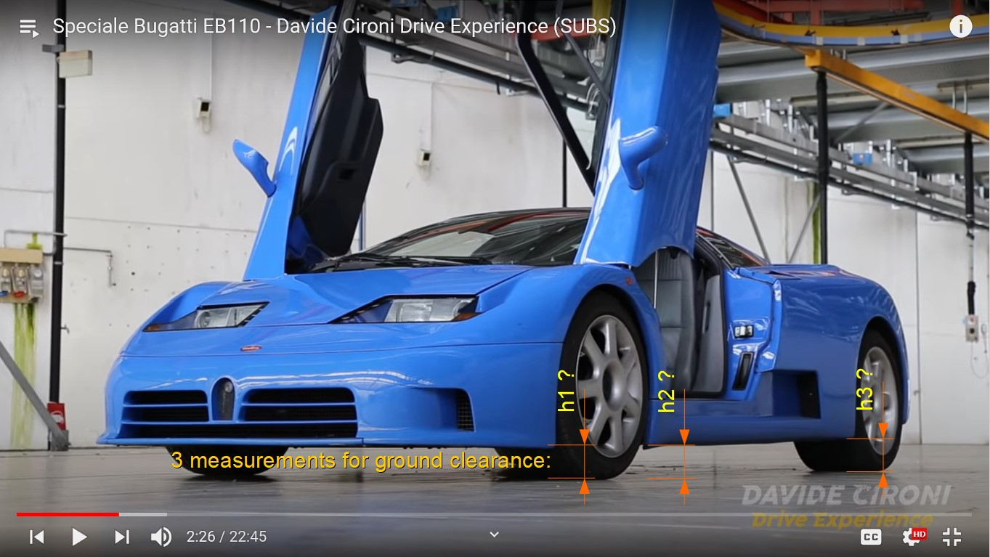

**Overall Controls & misc. info:**

WHEELBASE = 2,550 mm (from all sources)

Clearance (official) =130 mm (from “”, “” & “”)

Ground Clearance Rear = 128 mm (from “Rear Susp. schematics 08-10-1993”)

Ground Clearance Front = 115.5 mm (from “Front Susp. schematics 08-10-1993”)

Steering wheel diameter = 350 mm (“” data + confirmed in other sources both for GT & SS)

Force to turn a steering wheel while driving = 39 N (“” data)

Force to turn a steering wheel while stationary = 41 N (“” data)

Force to press gas pedal = 32 N (“” data)

Force to press clutch pedal = 180 N (“” data)

Force to press brake pedal (warm brakes) = 420 N (“” data)

Force to press brake pedal (cold brakes) = 390 N (“” data)

Interior Noise at constant 50 km/h = **70 dBA** (according to “”

Interior Noise at constant 100 km/h = **77 dBA** (according to “”

Interior Noise at constant 130 km/h = **79 dBA** (according to “”

Interior Noise at constant 160 km/h = **82 dBA** (according to “”

Interior Noise at constant 200 km/h = **85 dBA** (according to “”

Interior Noise at idle in neutral = **67 dBA** (according to “”)

Interior Noise at max rpm in 1st gear = **85 dBA** (according to “”)

Interior Noise at constant 80 km/h = **74 dBA** (according to “”)

Interior Noise at constant 113 km/h = **77 dBA** (according to “”)

**car.ini**

|  |  |  |  |  |
| --- | --- | --- | --- | --- |
| Is OK? | Parameter | Value | Explanation | Data Source |
|  | **[BASIC]** |  |  |  |
| OK | TOTALMASS= | **1796** + 75 - (120*0,76)= **1780** kg | total vehicle weight in kg with driver and no fuel  (true weight + 75kg driver – weight of 120 liters of fuel) | “” data: true weight = **1796** kg  “” data: true weight = **1796** kg (factory data: 1620 kg)  “” data: true weight = **1790** kg (factory data: 1690 kg)  “” data: Kerb weight = 1620kg |
| Help!  or  To be tuned? | **INERTIA**= | 1.94,1.114,4.40 | “car polar inertia. Calculated from the car dimensions. Just enter the generic width, height“  (effectively car body dimensions in meters)  Car is “modeled as a solid cuboid of height h, width w, and depth d, and mass m.. So if you have the inertia values you can deduct what AC is asking for (height h, width w, and depth d of this cuboid)” using formulas from <http://en.wikipedia.org/wiki/List_of_moments_of_inertia>  “If you're more advanced, you have two options:  1. Calculate all the inertias (if you have the data) in whatever app you want to use. Get the values and …”  use “**[EXPLICIT_INERTIA]** ;required header  **INERTIA=1300,1400,500** ;this code enables direct input of inertia values and overrides the box inertia parameter, recommended for use with real life data"  “2. Roughly insert the dimensions of the car. We advice a longer box than the car for front engine/weight cars, and a smaller box than the car for middle engined cars. Then, ingame open the **CAR PHYSICS dev app** and check the "**DINDEX**" value. This is a perfect help to better understand how to setup the car in terms of inertia. Search Dynamic Index car engineering on google for more info if you're not aware of the term.  I'll get back to the subject with more info, at a later time. Trust me, D Index is VERY good value.” | Actual inertia values would be nice,  Dimensions data:  “” data: W,H,L = 1940, 1125, 4400 mm  “” data: W,H,L = 1940, 1125, 4400 mm  “Gente Motori, (Aug1993)” data: W,H,L = 1.9**6** m, 1.13 m, 4.40 m  “” data: W,H,L = 1940, **1114**, 4400 mm  “” data: W,H,L = no data, **1114**, 4400 mm  “” & “” data: W,H,L = 1940, 1125, 4400 mm |
|  |  |  |  |  |
|  | **[GRAPHICS]** |  |  |  |
| Help! | FUEL_LIGHT_MIN_LITERS= | 10 | How many liters of fuel must be left to turn on “low fuel” warning light? |  |
|  |  |  |  |  |
|  | **[CONTROLS]** |  |  |  |
| To be tuned | FFMULT= | 1.45 | Force Feedback power multiplayer | Inspired by BMW E30 M3 & Nissan R34  According to “”, “” and other sources, all EB110 (GT and SS) had hydraulic power stering by ZF + 350mm diameter steering wheels.  Force to turn a steering wheel while driving = 39 N +  Force to turn a steering wheel while stationary = 41 N (“” data) |
| ok? | STEER_ASSIST= | 1.000 | Variable steer assist, speed relative | Typical value in Assetto Corsa |
| ok? | STEER_LOCK= | 495 (which is 990 deg lock-to-lock) | Real car's steer lock from center to right  360deg x 2.75 x 0.5 | “” data: lock-to-lock = **2.75** turns  “” data: lock-to-lock = **2.75** turns  “” data: lock-to-lock = 2.9 turns  <https://www.evo.co.uk/group-tests/14208/bugatti-eb110-meets-edonis-the-offspring> info: 2.8 turns |
| Help! | STEER_RATIO= | 17.32 | Steer ratio “For example, if one complete turn of the steering wheel, 360 degrees, causes the wheels to turn 24 degrees, the ratio is then 360:24 = 15:1.”  Calculation:  “turn radius” = (turning circle- CarWidth)/2 = (**12.6** - 1.94)/2 = 5.33m (for bicycle model)  “Wheel turn angle” ~ arcsin(wheelbase / turn radius) = arcsin(2.55 / 5.33) = **28.58deg**  “Steer Ratio” = 495 / 28.58 = 17.32 | Factory data could be great, but this data is quite good:  “” data: wall-to-wall turning circle Left/Right= **12.6**/12.7 m  “” data: turning circle = **12.6** m  “” data: turning circle = 11.9 m (curb-to-curb?)  (from “Front Susp. schematics 08-10-1993”):  Steering rack travel range (corsa cremagliera)? = 145 mm  Steering angle (angolo sterzata) = 30°53' / 28°29' = **30.88 / 28.48 deg** |
| To be tuned | LINEAR_STEER_ROD_RATIO= | 0.0021 | Because of AC complex suspension geometry, you need to calculate manually the steer rod ratio  “1. Create your suspension geometry and just copy the values for steering from the formula_k.  2. Set your STEER_RATIO= value inside car.ini file.  3. Go ingame and open SUSPENSION dev app.  4. turn your steering wheel at 90 degrees (left or right doesn't matter).  5. check on SUSPENSION dev app the line with light blue/azure font color inside brackets [STR:xx.x] number. That is your current steering ratio.  6. Exit the game and change the LINEAR_STEER_ROD_RATIO= value inside car.ini. Do small change like 0.00005 by time.  7. Go back in-game and re-check [STR:xx.x].  8. Repeat until the ingame STR value is similar to STEER_RATIO= value.” ([source](https://www.assettocorsa.net/forum/index.php?threads/answers-from-the-devs.12077/#post-201219)) |  |
|  |  |  |  |  |
|  | **[FUEL]** |  |  |  |
| To be tuned | CONSUMPTION= | 0.0046 | fuel consumption. In one second the consumption is (rpm*gas*CONSUMPTION)/1000 litres | Lots of sources in the reference magazines – you are welcome to dig through it. |
| OK | FUEL= | 30 | default starting fuel in litres |  |
| OK | MAX_FUEL= | 120 | max fuel in litres | “” data: 120 l  “” data: 120 l |
|  |  |  |  |  |
|  | **[FUELTANK]** |  |  |  |
| ok? | POSITION= | 0,-0.05,-0.50 | (body Left, body UP, body FORWARD) Tweaked to look fine. | Factory data could be great, but approximately everything is known.  Located behind the doors and in front of rear wheels, 2x 60l tanks on each side, |
|  |  |  |  |  |
|  | **[RIDE]** |  |  |  |
| To be tuned | PICKUP_FRONT_HEIGHT= | -0.250 | ??? “Height of the front ride height pickup point in meters WRT cg”  (if this is the height of lower control arms relative to the roll center, then the height is known from suspension diagrams.) |  |
| To be tuned | PICKUP_REAR_HEIGHT= | -0.28 | ??? |  |

## Important notes about Data sources

To correctly interpret the data sources please consider this:

1. **Not all EB110 cars of the same model are equal.** Some differences are only cosmetic (mirrors, rear logo, etc.), some things stayed the same (gear ratios) but the engines and suspension may differ. For example according to [EB110_Registry](http://yo.spc.free.fr/EB110_Registry.htm) the GT had two standard engine power outputs: “The GT version was powered with a 550 bhp V12 quadriturbo engine (+10 bhp engine evolution later).”
2. Bugatti was always a small company that used every available car/chassis they had to continuously develop the EB110. That means:
   1. **In some cases media was given upgraded cars for test drives.** Bugatti test cars and press cars are the same thing. For example a GT test-car may have been equipped with an engine that was in development for the SuperSport and the reviewers did not know that.
3. **Do not believe official performance certification data.** This is not limited to Bugatti, but most official performance certifications involve some unrealistic car preparation. Especially when world records are at stake. For example Bugatti record runs were done with only one mirror and duct-tape over all body gaps for better aerodynamics; the cars had minimal interior trim and maybe even engine modifications.
4. Official **specification sheets are not 100% reliable**. There are examples of basic numbers that are different from one Bugatti spec sheet to another.
   1. Marketing always tries to make numbers look as great as possible. For example, they may use theoretical, not actual values.
   2. As mentioned models evolved over time or there are simply mistakes in the published data.

Based on all the information above here are some data sources that are **quite reliable:**

* Sport Auto, n375 (May 1993, France) – very detailed independent test of EB110GT which performed as expected.
* Car Graphic, Road Test No.345 (199?, Japan) – the most precise independent performance measurement of EB110GT using a production model.
* Auto Motor und Sport, (May1993, Germany) – also detailed independent test of EB110GT which performed as expected.
* Factory data on certain components: gear ratios, suspension geometry and wheel alignment + other numbers that are likely to be correct.

Known independent tests that have **problematic data:**

* Road and Track, (July 1994, USA) – the GT car supposedly had non-standard 611 bhp engine and still showed very poor 0-60 mph performance.
* Gente Motori, (Aug1993, Italy) – the test car was likely too powerful for a normal GT spec.

## Sources of Data

Here is a list of all the key data sources used in for this document.

#### GT Spec sheet

Source: <http://yo.spc.free.fr/Bugatti%20register/EB110_GT/EB110GT.htm>

Note: see also “EB110 Tech Sources of data” document for the key data.

#### SS Spec sheet

Source: <http://yo.spc.free.fr/Bugatti%20register/EB110_Supersport/EB110SS.htm>

Note: see also “EB110 Tech Sources of data” document for the key data.

#### S Spec sheet (early version of SS)

Source: <https://www.deviantart.com/pzlwksmedia/art/EB110-Tech-P1-Web-3-364234236>

Note: see also “EB110 Tech Sources of data” document for the key data.

#### GT and S Brochure (early version of SS)

Source: <https://ruoteleggendarie.com/portfolio_page/bugatti-il-sogno-mancato/>

Note: see also “EB110 Tech Sources of data” document for the key data.

#### Front Susp. schematics 08-10-1993

Source: <http://yo.spc.free.fr/EB110_Registry.htm> (the initial document available from source on request, cannot share it)

The suspension is re-modelled and re-measured in Assetto Corsa wheel centered coordinates by Sergejs:

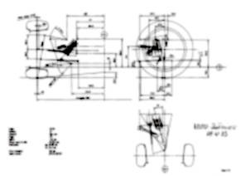

The Solvspace CAD files for suspension geometry are available together with Blender 3D file.

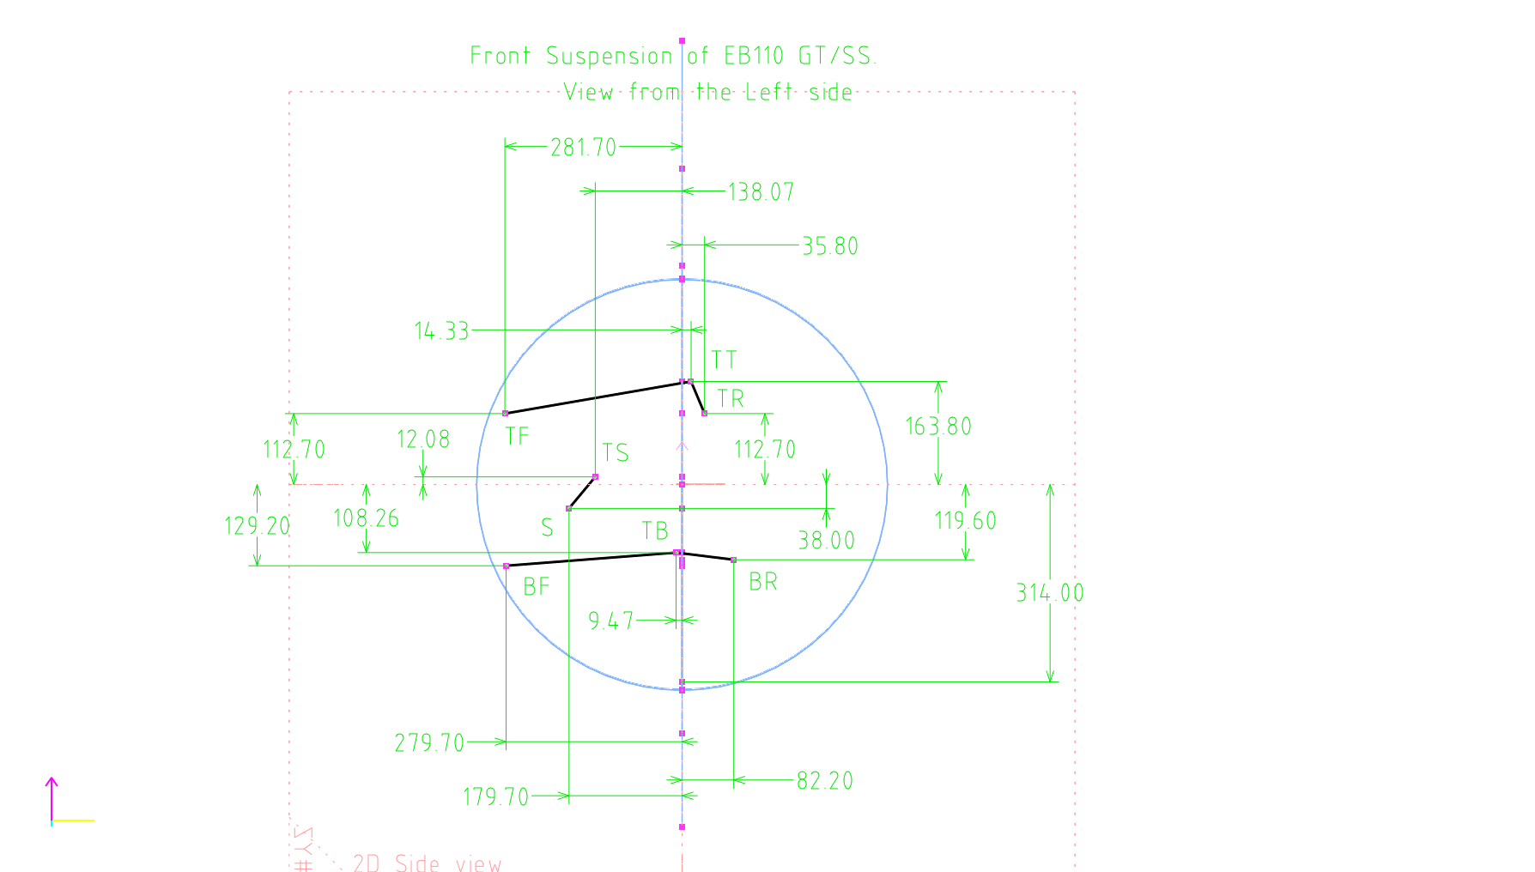

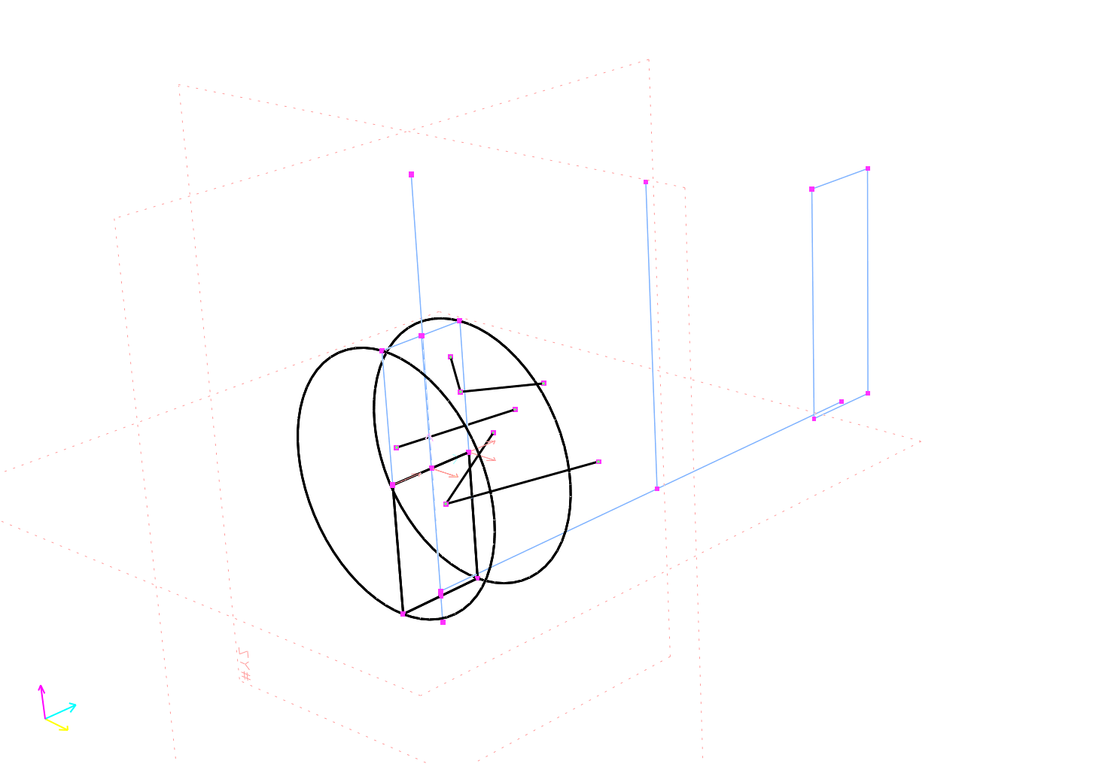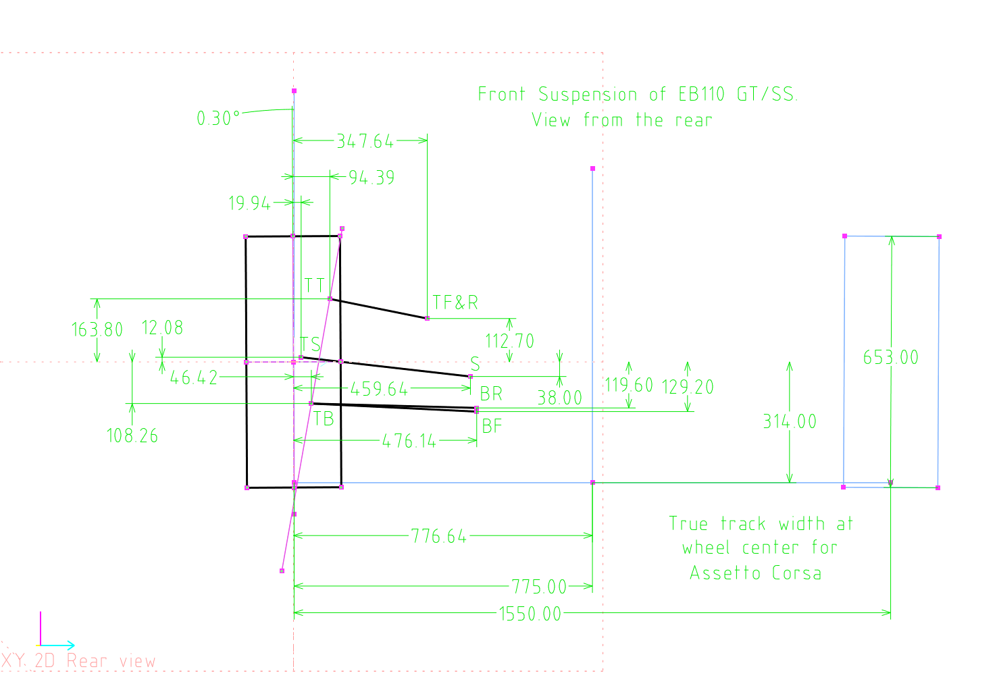

#### Rear Susp. schematics 08-10-1993

Source: <http://yo.spc.free.fr/EB110_Registry.htm> (the initial document available from source on request, cannot share it)

The suspension is re-modelled and re-measured in Assetto Corsa wheel centered coordinates by Sergejs:

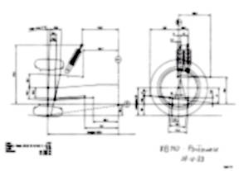

The Solvspace CAD files for suspension geometry are available together with Blender 3D file.

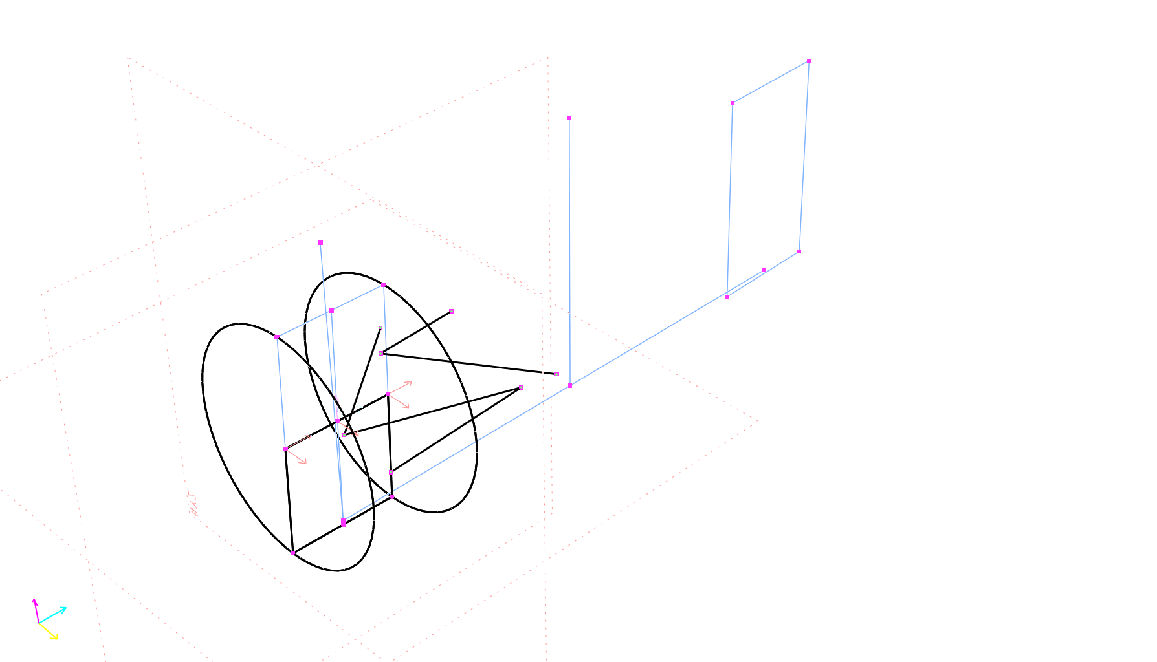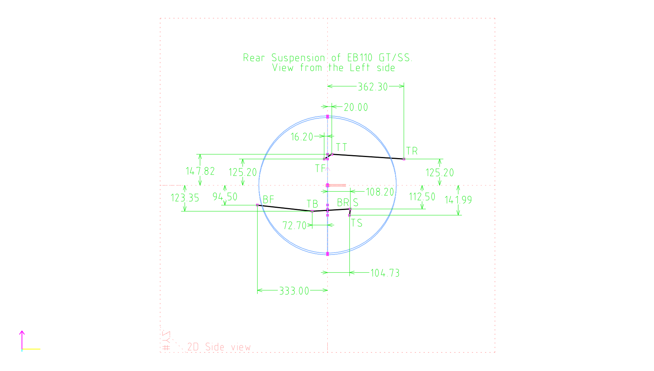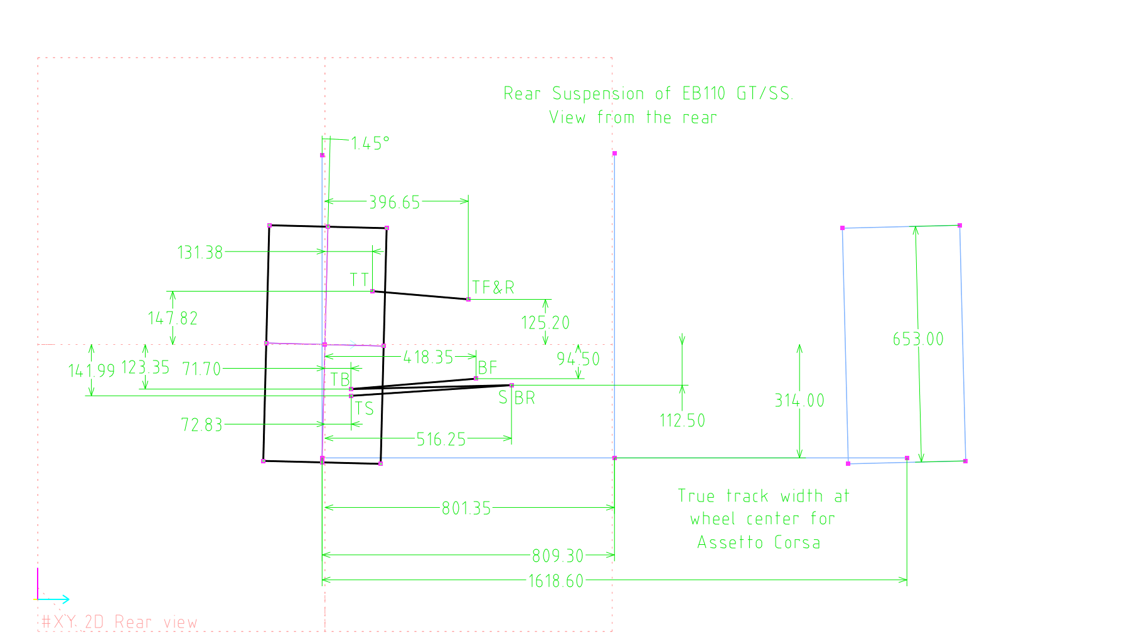

#### Sport Auto, n375

(May 1993, France) Source: <https://www.autotitre.com/forum/Bugatti/EB110/Bugatti-EB110-Magazine-articles-scans-108001p1.htm>

Note: see also “EB110 Tech Sources of data” document for the key data. 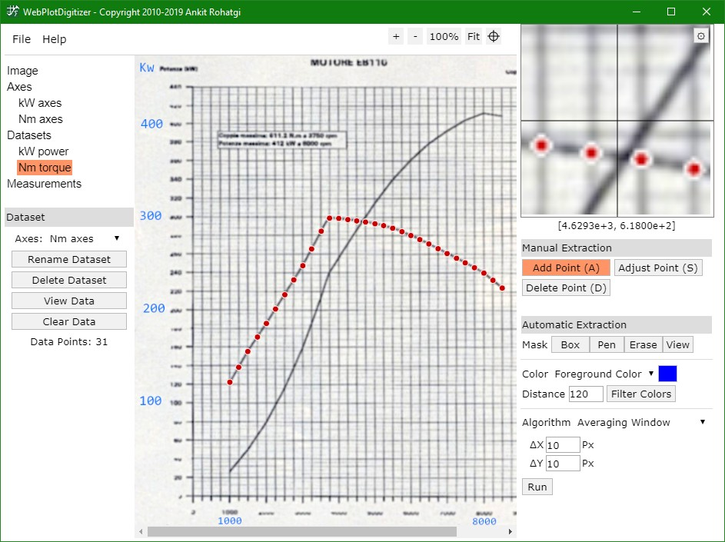

#### Car Graphic, Road Test No.345

(199?, Japan) Source: <https://www.autotitre.com/forum/Bugatti/EB110/Bugatti-EB110-Magazine-articles-scans-108001p1.htm>

Note: see also “EB110 Tech Sources of data” document for the key data.

#### Auto Motor und Sport, (May1993)

(Germany) Source: <https://www.autotitre.com/forum/Bugatti/EB110/Bugatti-EB110-Magazine-articles-scans-108001p1.htm>

Note: see also “EB110 Tech Sources of data” document for the key data.

#### Road and Track, (July 1994)

(USA) Source: <https://www.autotitre.com/forum/Bugatti/EB110/Bugatti-EB110-Magazine-articles-scans-108001p1.htm>

Note: see also “EB110 Tech Sources of data” document for the key data.

#### Gente Motori, (Aug1993)

(Italy) Source: <https://www.autotitre.com/forum/Bugatti/EB110/Bugatti-EB110-Magazine-articles-scans-108001p1.htm>

Note: see also “EB110 Tech Sources of data” document for the key data.

#### CAR magazine (March 1994)

No data. Source: <https://www.autotitre.com/forum/Bugatti/EB110/Bugatti-EB110-Magazine-articles-scans-108001p1.htm>

Note: see also “EB110 Tech Sources of data” document for the key data.

#### Differentials of the 1993 EB110GT (047)

Source: <https://inventory.symbolicinternational.com/vehicles/119/1993-bugatti-eb110-gt>; <https://classiccars.com/listings/view/1183350/1993-bugatti-eb-110-for-sale-in-san-diego-california-92121> & [Bugatti EB110GT - chassis GT047 (free.fr)](http://yo.spc.free.fr/Bugatti%20register/EB110_GT/39047.htm)

Note: see also “EB110 Tech Sources of data” document for the key data.

#### Bugatti EB110: a Drivetrain Analyzed

(2018 by DataHunter) Source: <https://supercarengineering.wordpress.com/2018/07/01/the-journey-begins/>

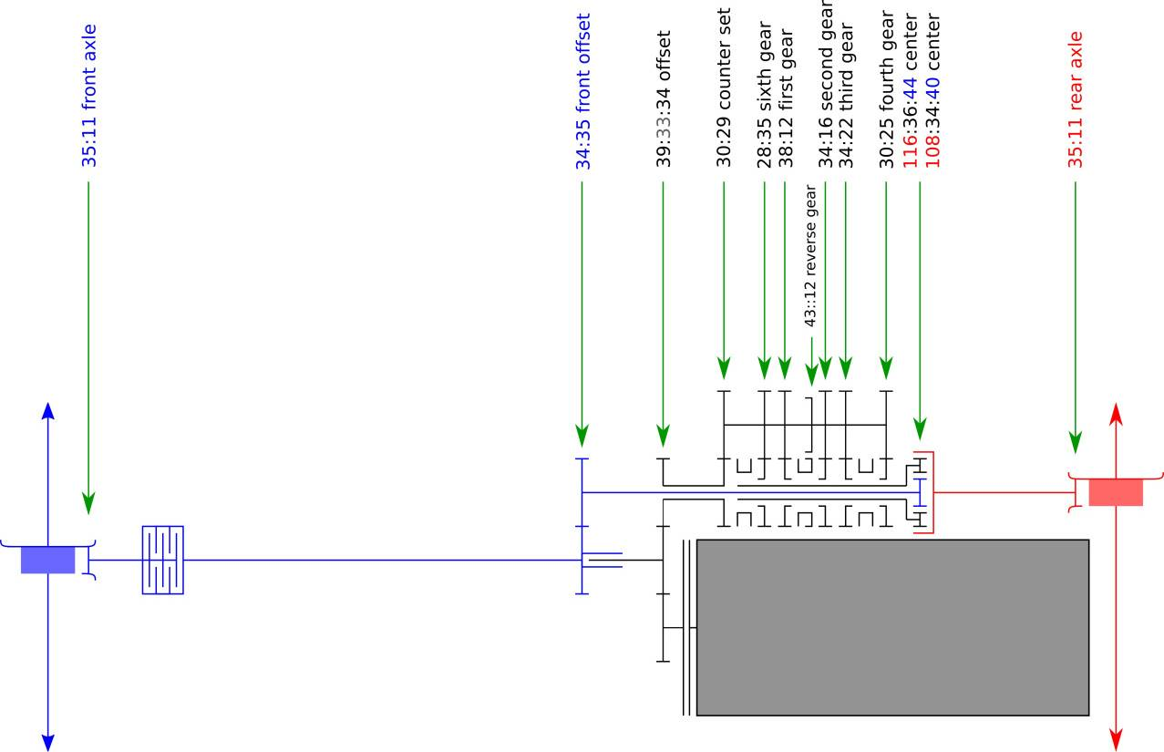

**Use this for whatever you want!**

Copyright 2020 Sergejs (and **all contributors**)

Licensed under the Apache License, Version 2.0 (the "License");

you may not use this file except in compliance with the License.

You may obtain a copy of the License at

<http://www.apache.org/licenses/LICENSE-2.0>

Unless required by applicable law or agreed to in writing, software distributed under the License is distributed on an "AS IS" BASIS,

WITHOUT WARRANTIES OR CONDITIONS OF ANY KIND, either express or implied.

See the License for the specific language governing permissions and limitations under the License.